AWS S3 Tasks
Task 1: Create an Amazon S3 Bucket and Upload Objects
Objective
Create an Amazon S3 bucket and upload sample files (objects) into the bucket.
Prerequisites
- AWS Account
- IAM User with S3 permissions
- AWS Management Console access
Step 1: Login to AWS Console
- Sign in to the AWS Management Console.
- Search for Amazon S3 in the search bar.
- Open the S3 service.
Step 2: Create an S3 Bucket
- Click Create bucket.
- Enter a unique bucket name.
Example: divya-s3-demo-bucket-2026
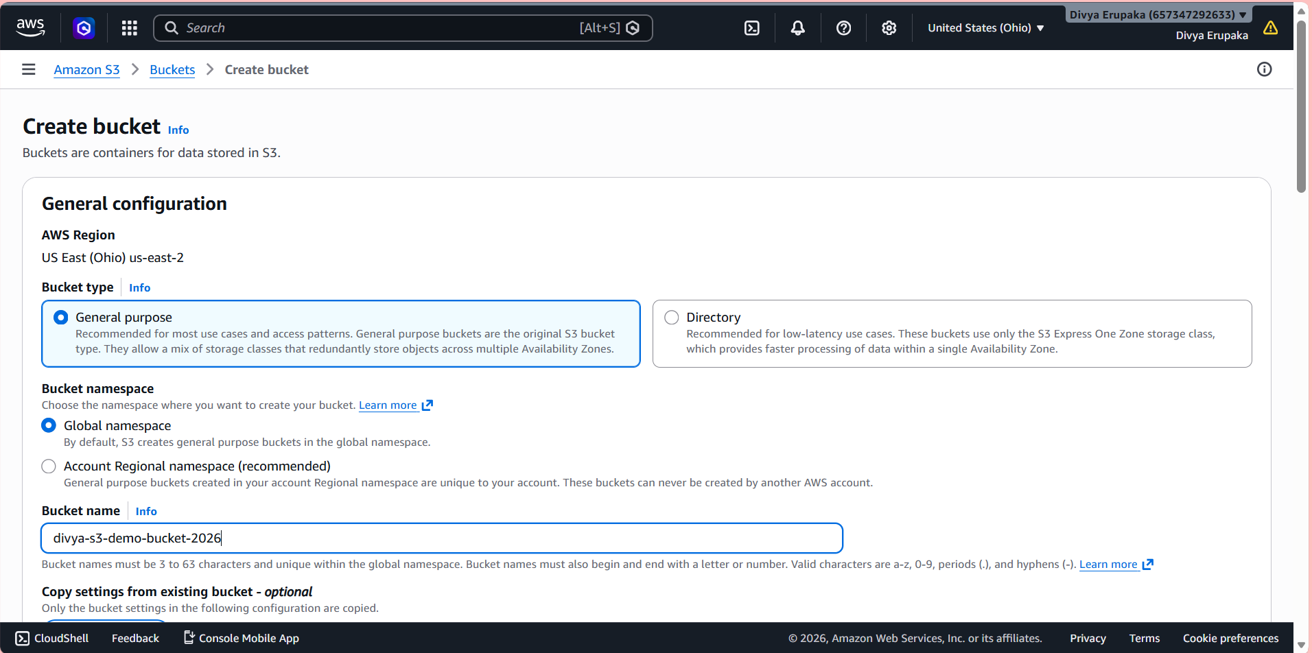
- Select the AWS Region.
Example:
ap-south-1 (Mumbai)
- Leave the remaining settings as default.
- Click Create bucket.
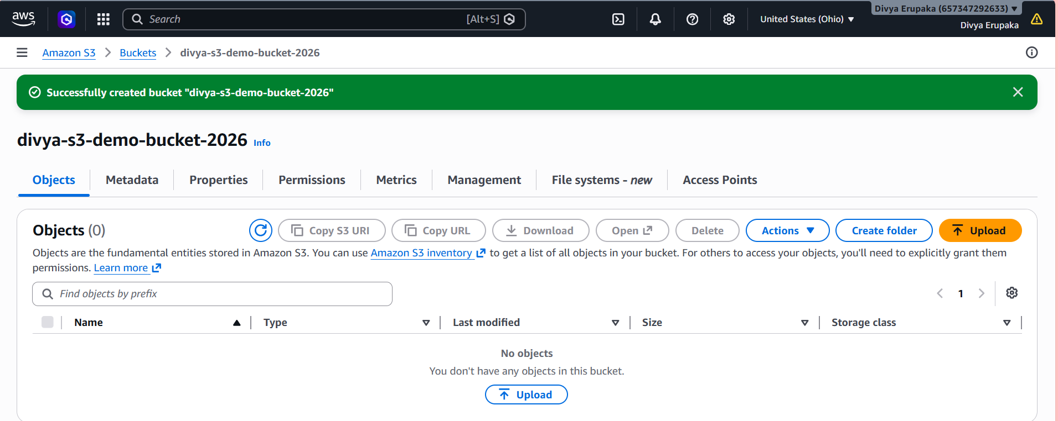
Expected Output
The bucket should appear in the S3 bucket list with status Available.
Step 3: Upload Objects to the Bucket
- Open the newly created bucket.
- Click Upload.
- Click Add files.
- Select sample files from your local machine.
Examples:
test1.txt
image.jpg
sample.pdf
- Click Upload.
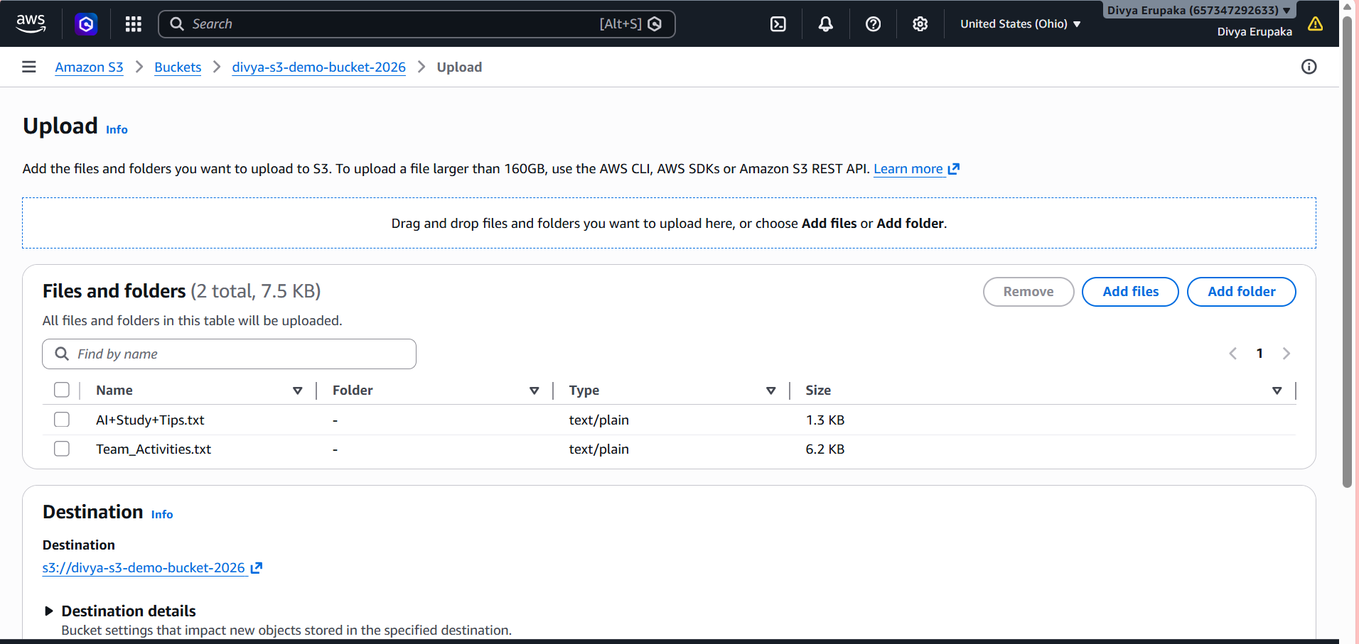
Expected Output
Files should be visible under the bucket's Objects tab.
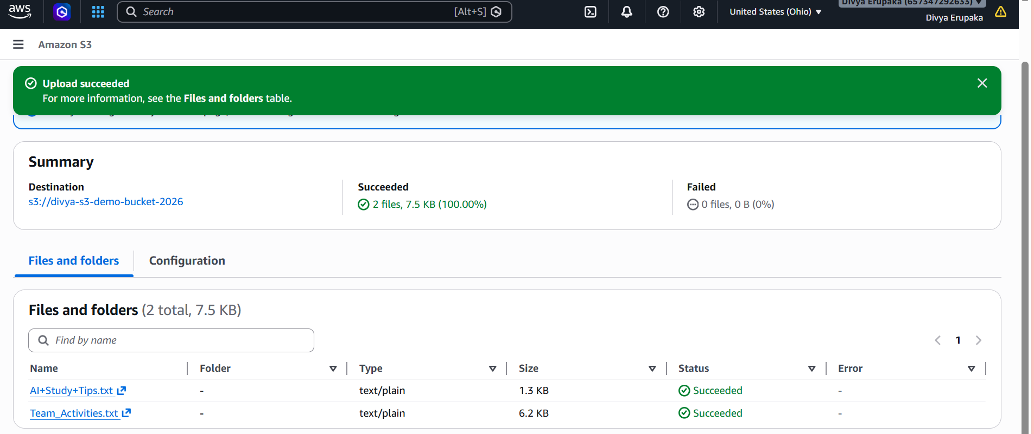

Result
Successfully created an Amazon S3 bucket and uploaded sample objects to the bucket. Verified that the uploaded files are available under the Objects section of the bucket.
Task 2: Deploy a Static Website in an Amazon S3 Bucket
Objective: Host a static website using Amazon S3 and access it through the S3 website endpoint.
Prerequisites
- AWS Account
- Existing S3 Bucket (created in Task 1)
- Sample website files:
  - index.html
  - error.html

Website Files
index.html
Create a file named index.html.
<!DOCTYPE html>
<html>
<head>
<title>My S3 Static Website</title>
</head>
<body>
<h1>Welcome to My Static Website</h1>
<p>Hosted on Amazon S3.</p>
</body>
</html>
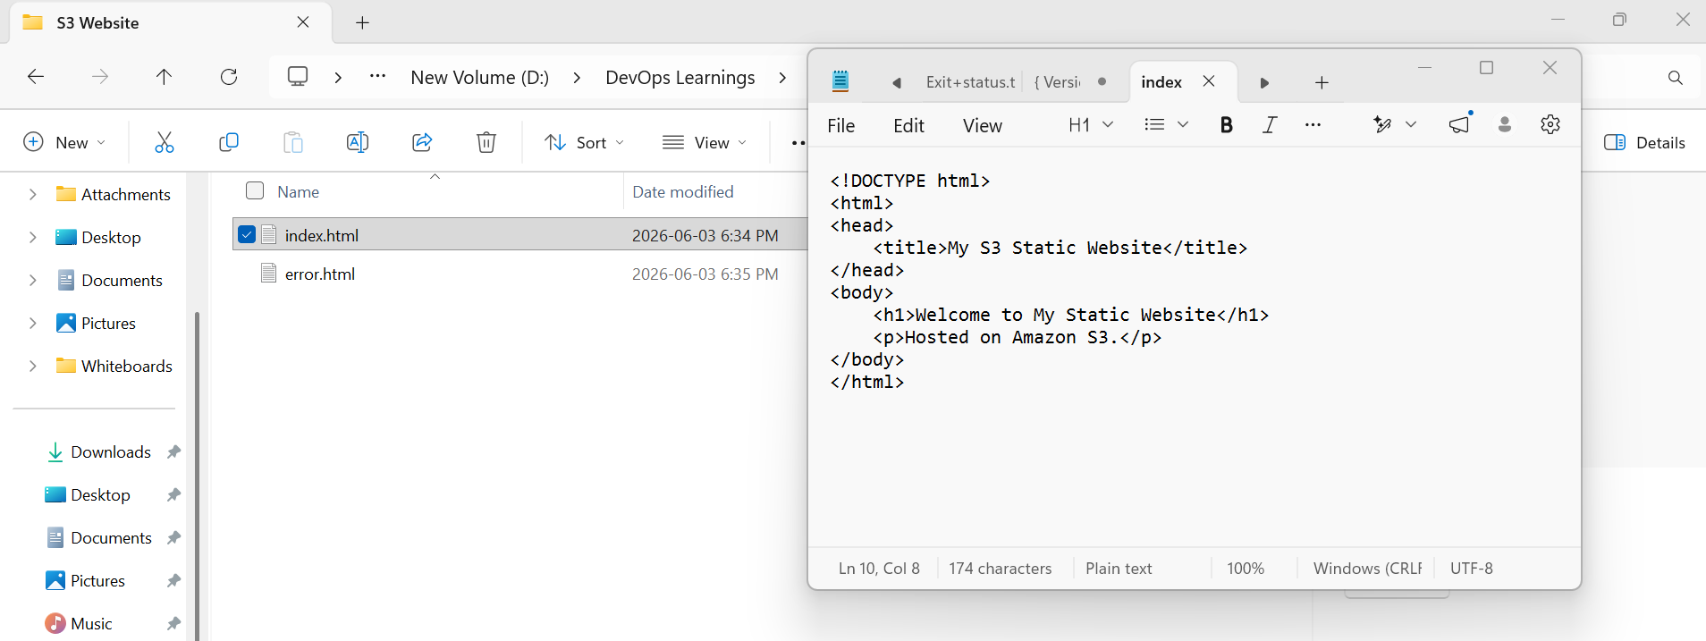
error.html
<!DOCTYPE html>
<html>
<head>
<title>Error Page</title>
</head>
<body>
<h1>404 Error</h1>
<p>Page not found.</p>
</body>
</html>
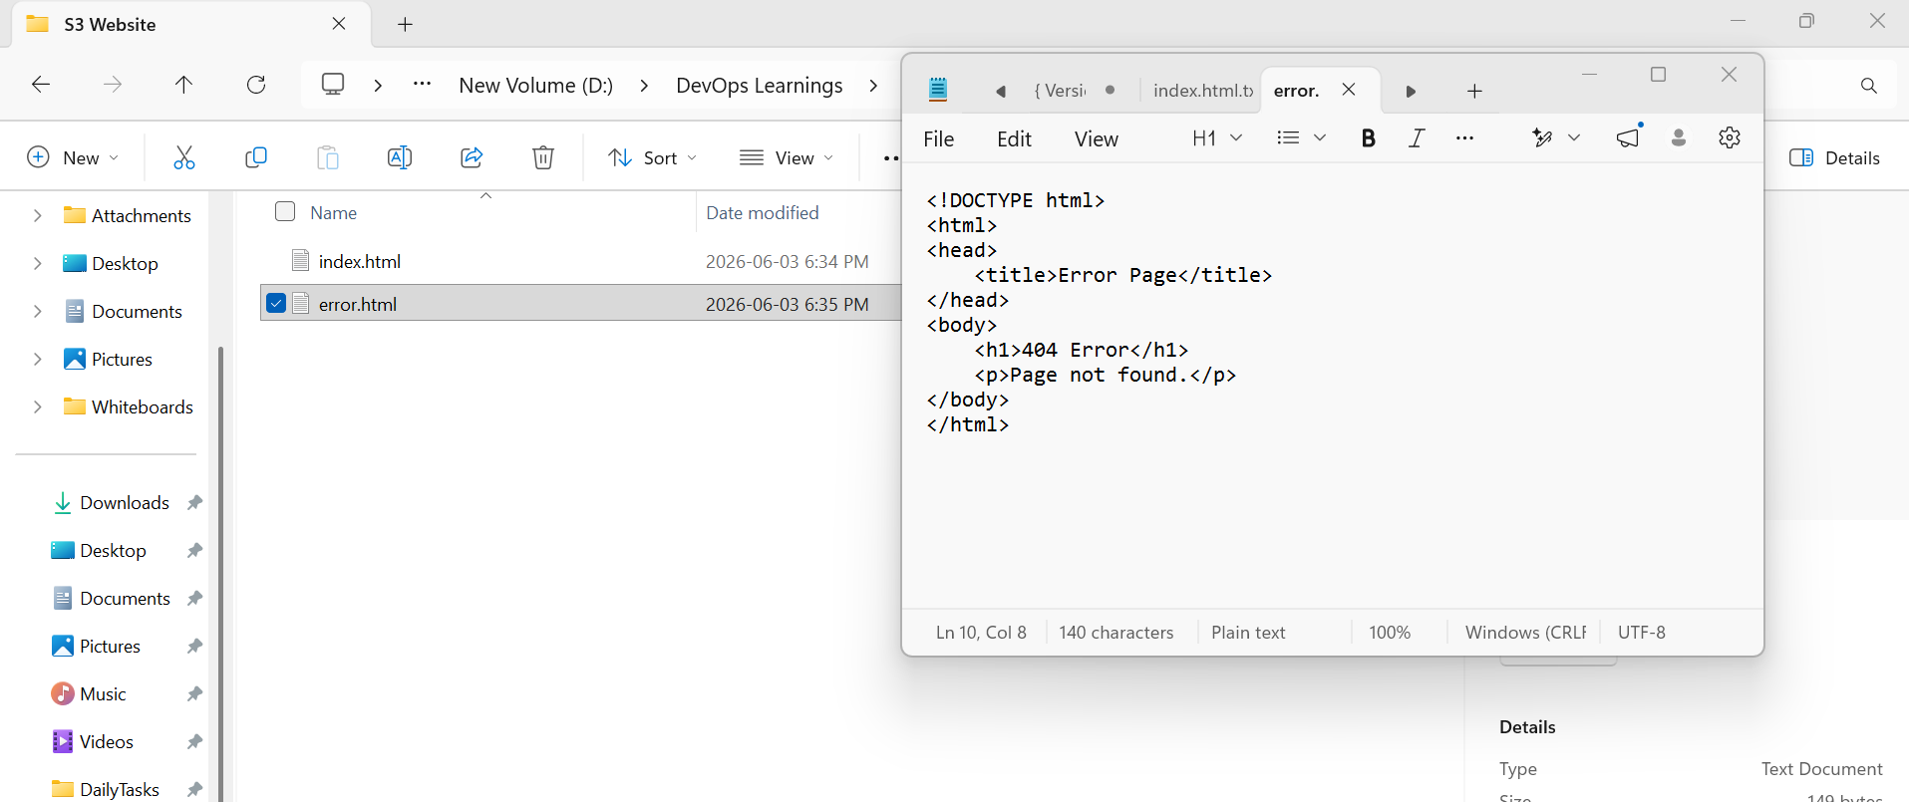
Step 1: Upload Website Files
- Open AWS Console.
- Navigate to S3.
- Open your bucket.
- Click Upload.
- Upload:
  - index.html
  - error.html
- Click Upload.
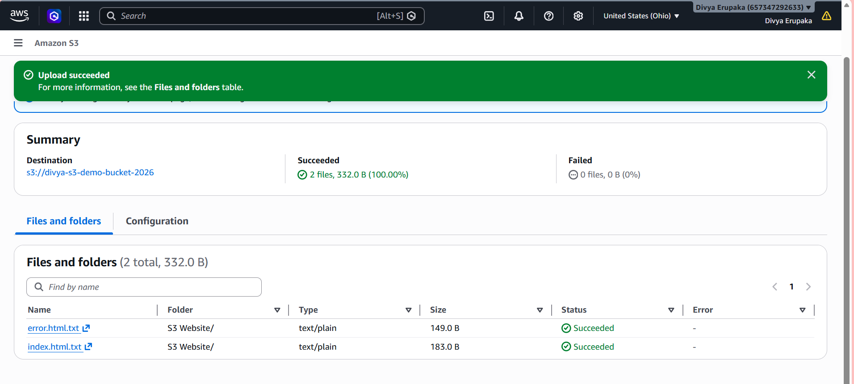Step 2: Enable Static Website Hosting
- Open the bucket.
- Select Properties tab.
- Scroll to Static website hosting.
- Click Edit.
- Choose:
Enable
- Hosting Type:
Host a static website
- Index document:
index.html
- Error document:
error.html
- Click Save Changes.
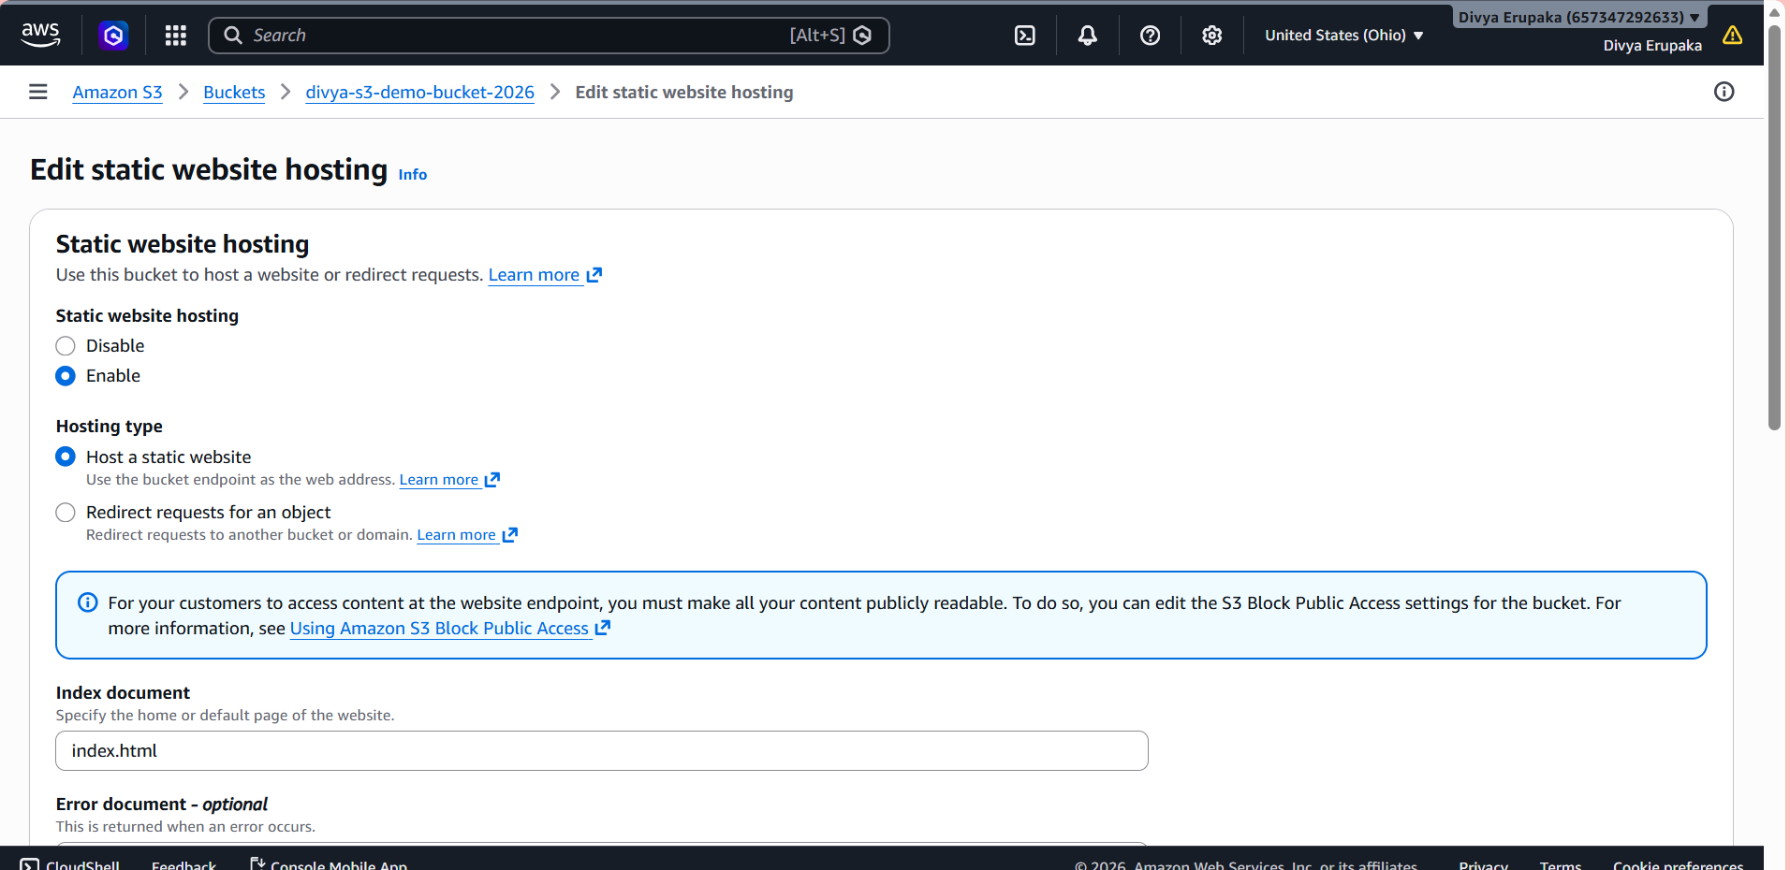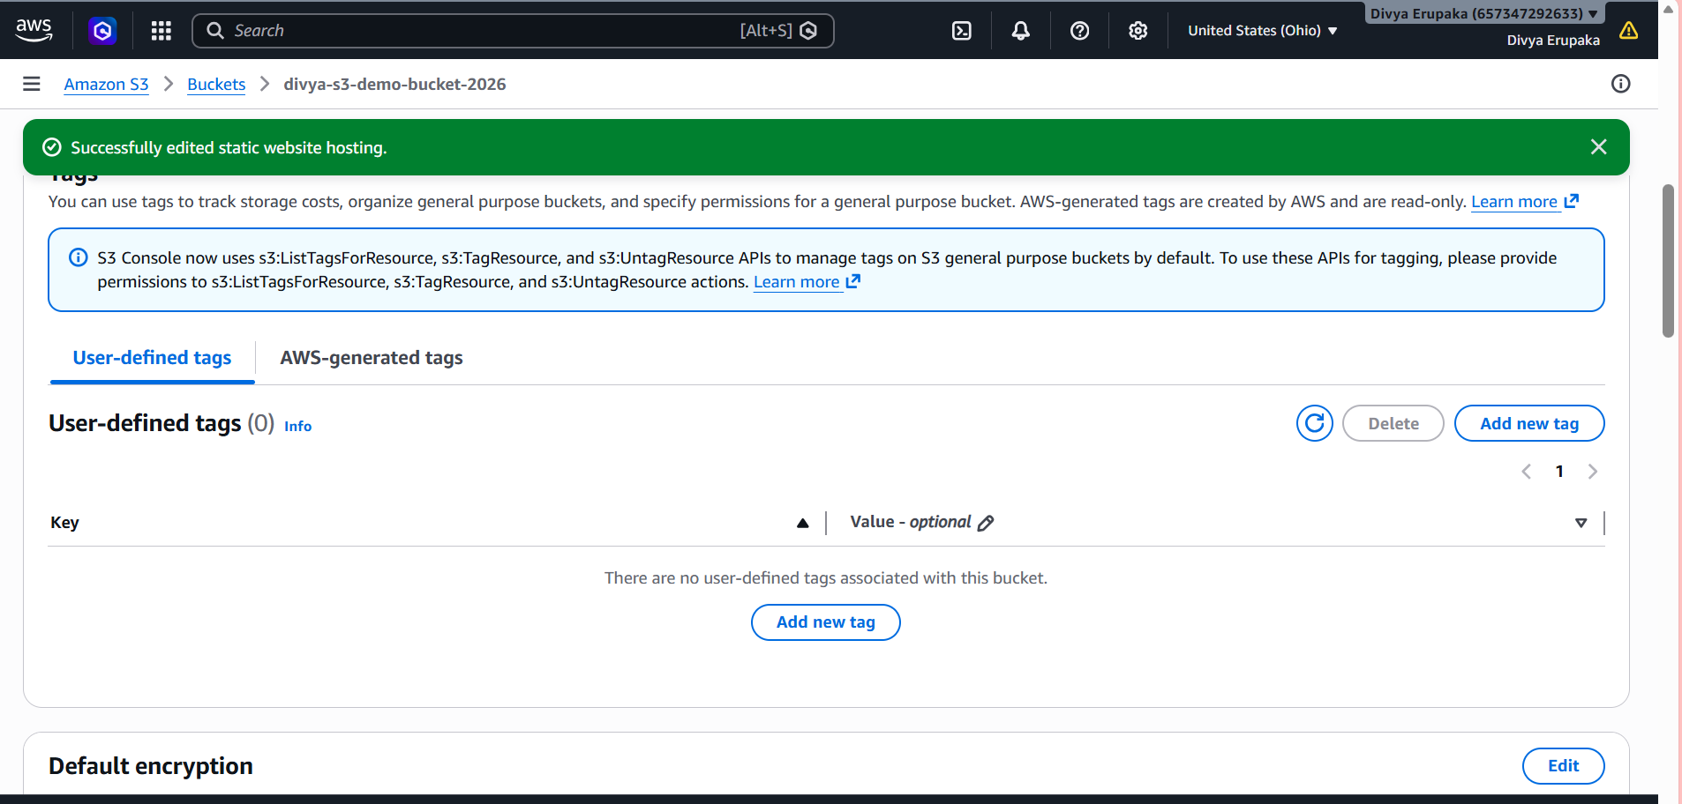
Step 3: Make Objects Public
By default, S3 blocks public access.
Disable Block Public Access
- Open bucket.
- Go to Permissions tab.
- Under Block Public Access, click Edit.
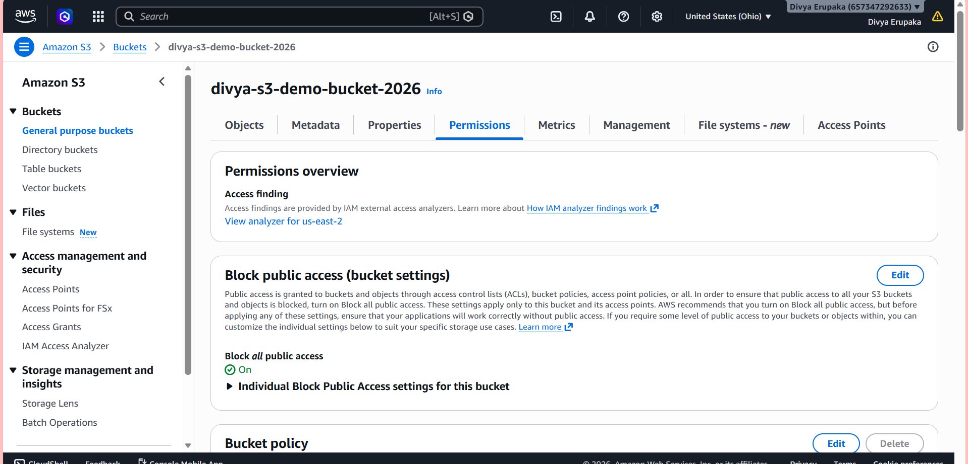
- Uncheck: Block all public access
- Save changes.
- Type: confirm
- Save.
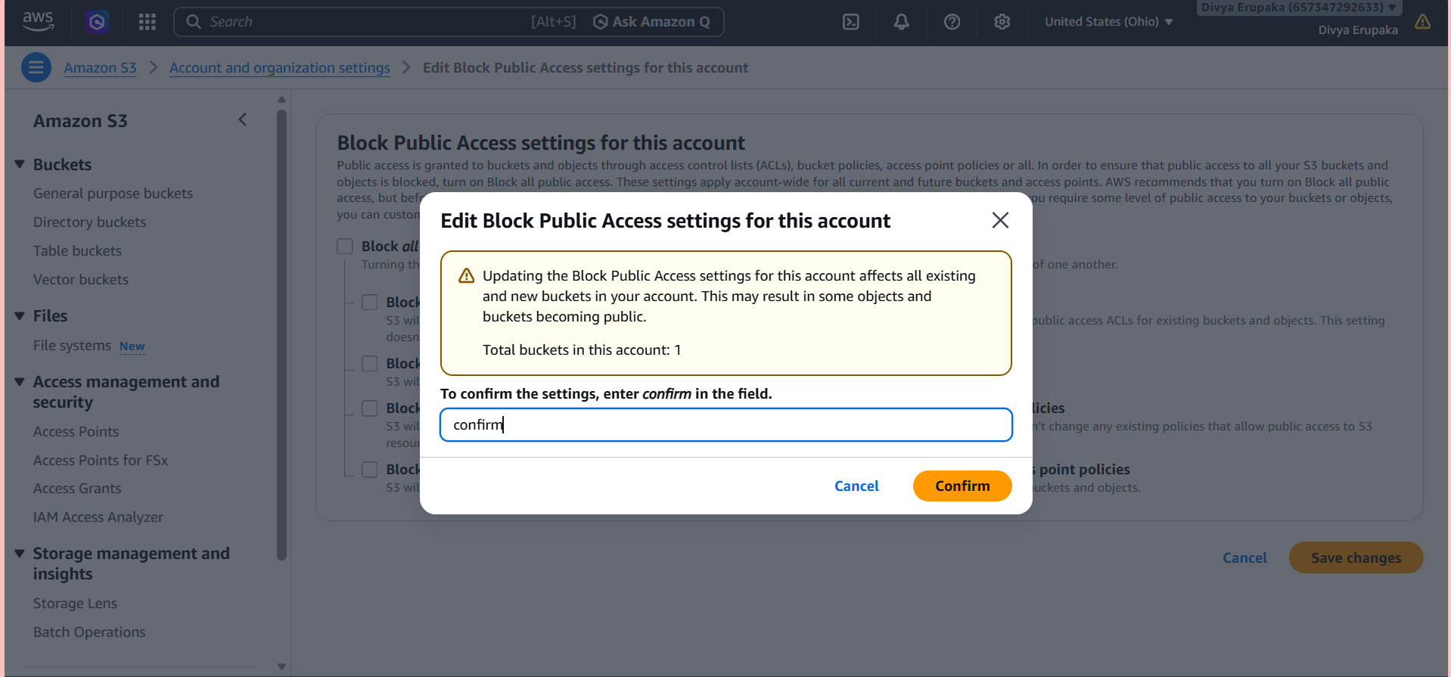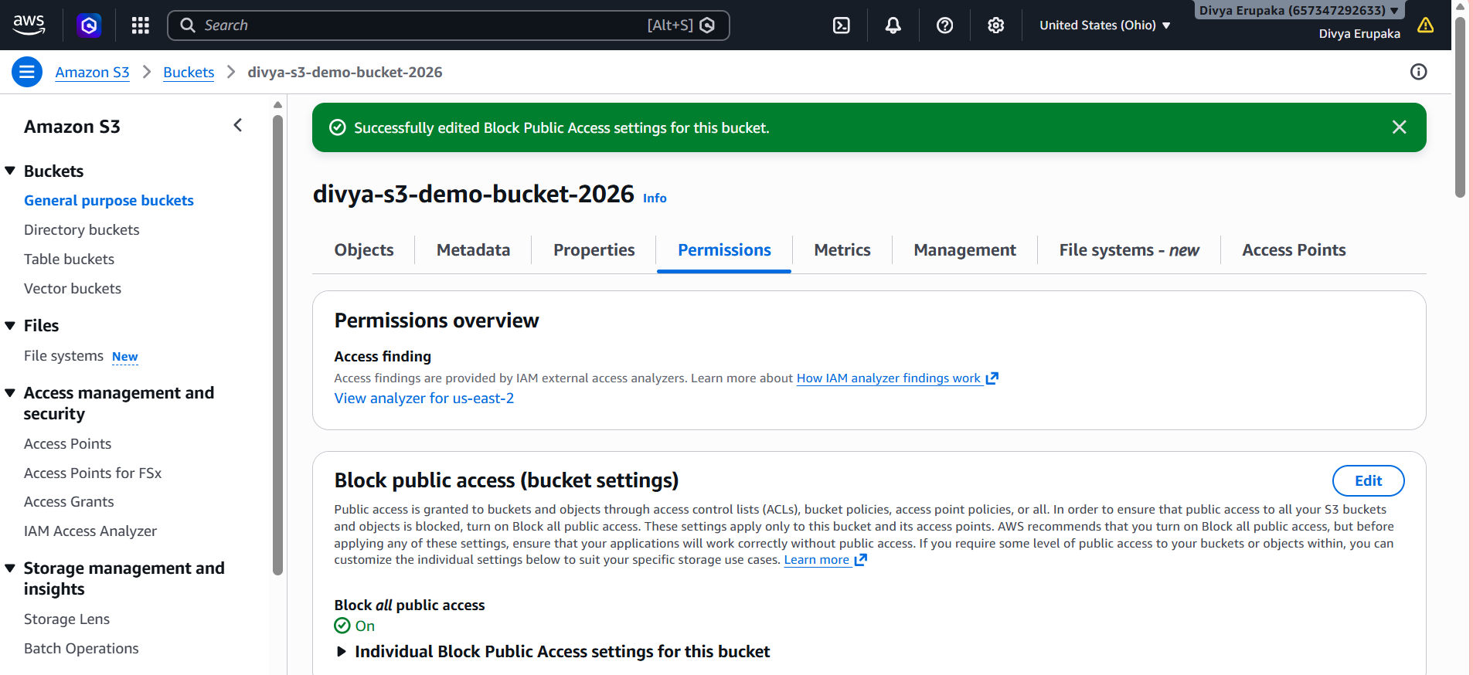
Step 4: Add Bucket Policy
Navigate to: Bucket
→ Permissions
→ Bucket Policy
Add the following policy:
Replace YOUR_BUCKET_NAME with your actual bucket name.
{
"Version": "2012-10-17",
"Statement": [
{
"Sid": "PublicReadAccess",
"Effect": "Allow",
"Principal": "*",
"Action": "s3:GetObject",
"Resource": "arn:aws:s3:::YOUR_BUCKET_NAME/*"
}
]
}
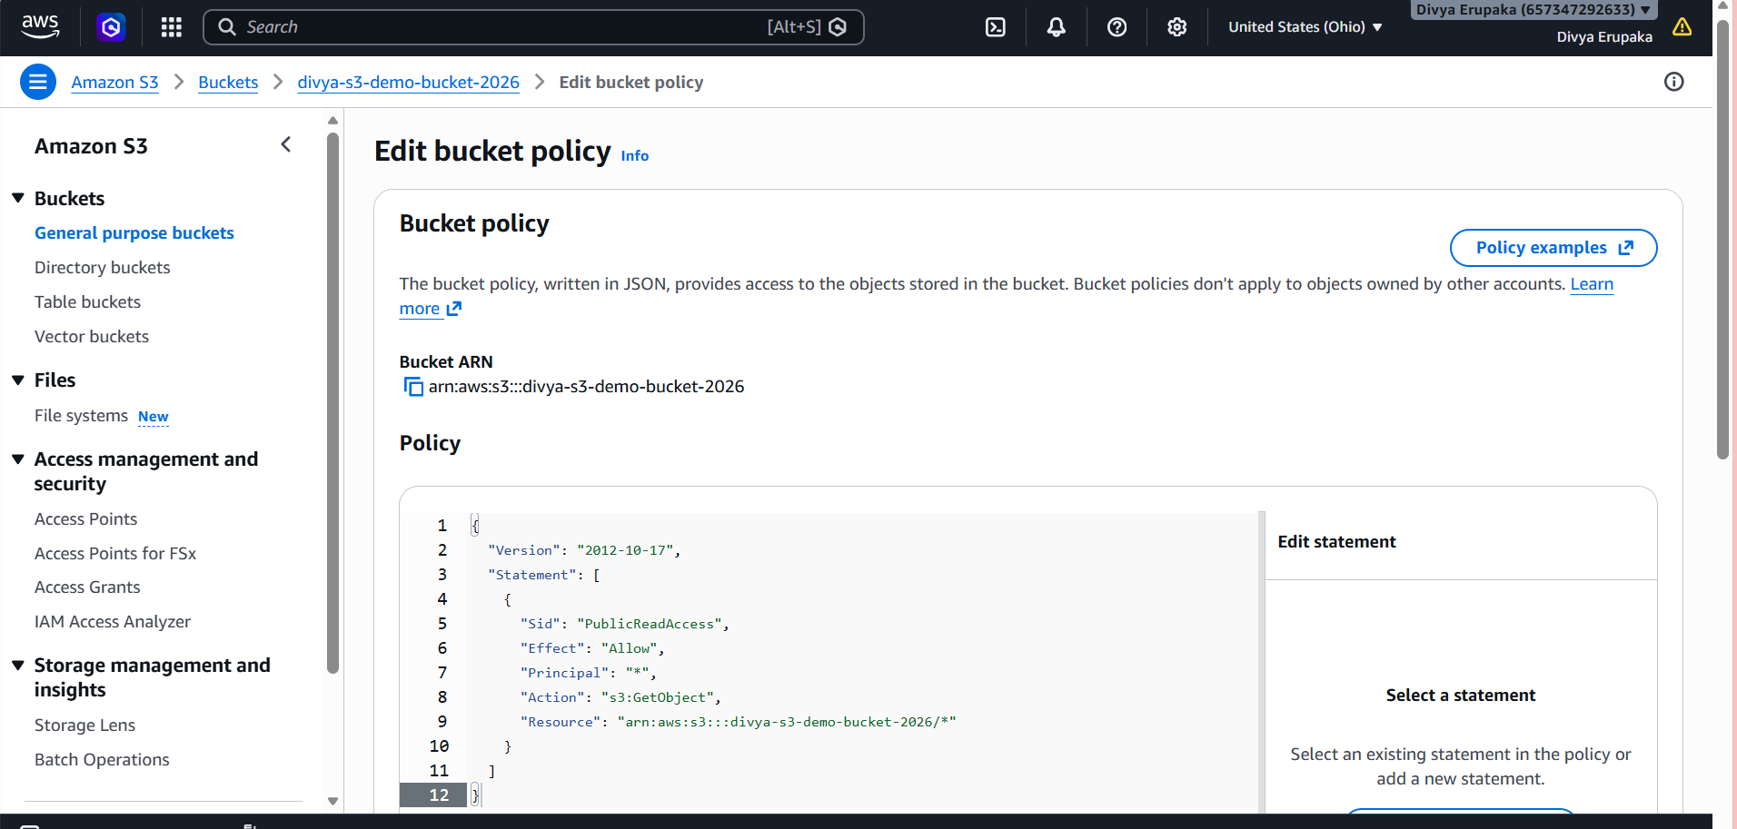
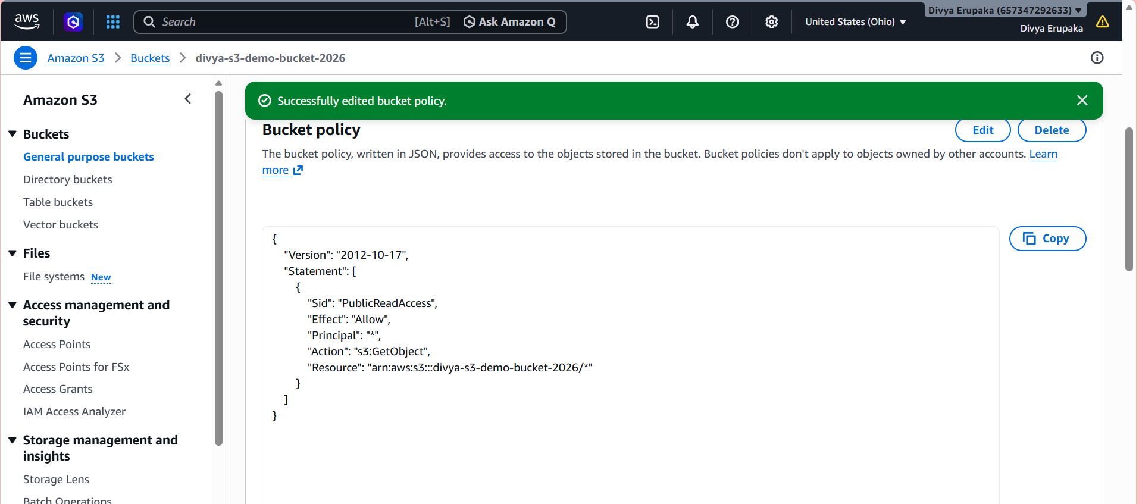
Click Save Changes.
Step 5: Access the Website
- Go to: Bucket
→ Properties
→ Static Website Hosting
- Copy the Website Endpoint URL.
Example: http://divya-s3-demo-bucket-2026.s3-website-ap-south-1.amazonaws.com
- Open the URL in a browser.
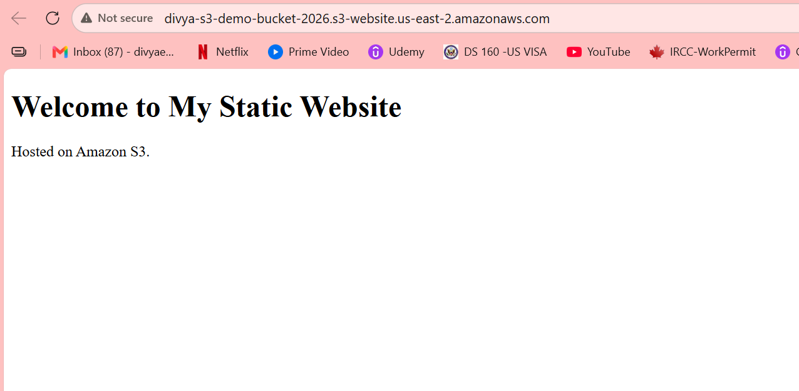
Verification
Expected Output:
Welcome to My Static Website
Hosted on Amazon S3.
The webpage should load successfully from the S3 website endpoint.
Validation Tests
Test 1: Home Page
Open:
http://bucket-name.s3-website-region.amazonaws.com
Expected Result:
Website loads successfully
Test 2: Error Page
Open:
http://bucket-name.s3-website-region.amazonaws.com/test
Expected Result:
404 Error
Page not found.
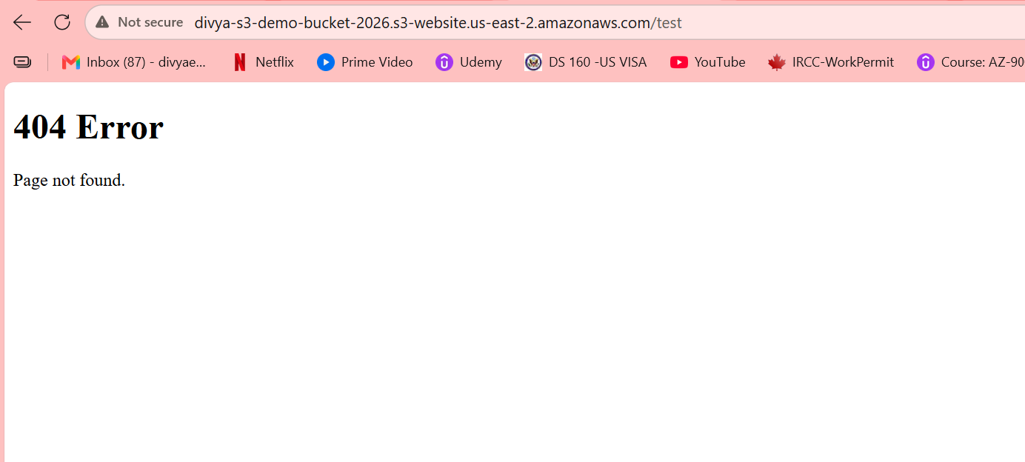
Result
Successfully configured Amazon S3 Static Website Hosting, uploaded website files, configured public access permissions, and accessed the website through the S3 website endpoint.
Task 3: Enable Cross-Region Replication (CRR) on S3 Buckets
Objective: Configure Amazon S3 Cross-Region Replication (CRR) to automatically replicate objects from a source bucket in one AWS Region to a destination bucket in another AWS Region.
Prerequisites
Before starting, ensure:
- Versioning is enabled on both buckets.
- You have permissions to create IAM roles and replication rules.
- Two S3 buckets exist in different regions.
Step 1: Create Destination Bucket
- Open AWS Console.
- Navigate to S3.
- Click Create bucket.
- Enter bucket name: destination-bucket-divya
- Select a different region than the source bucket.
- Click Create bucket.
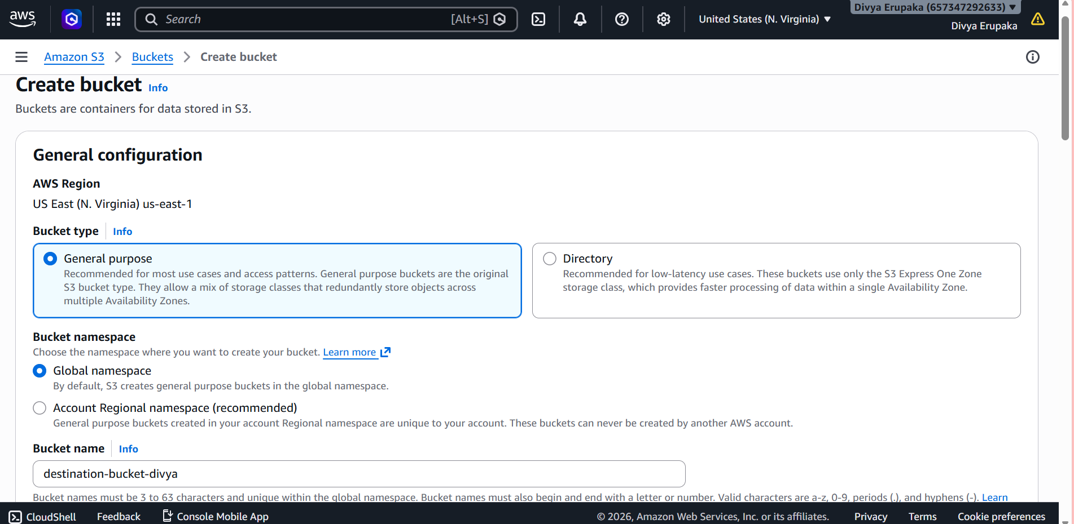
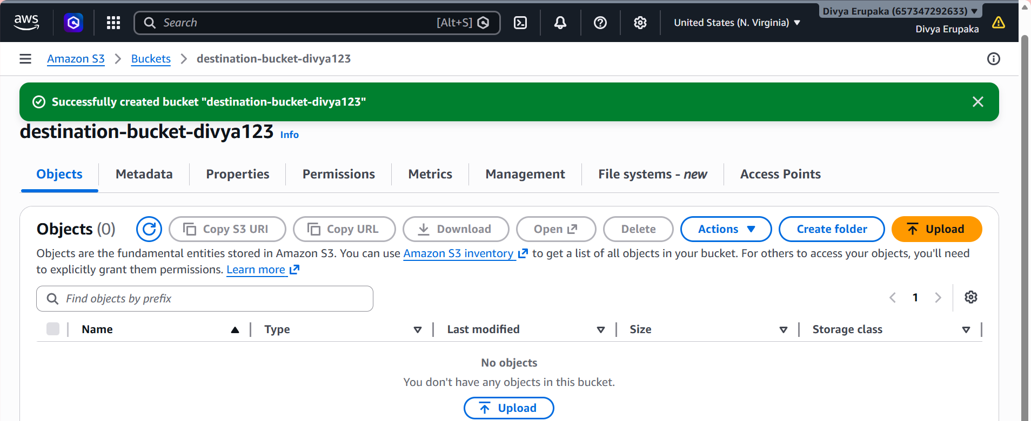
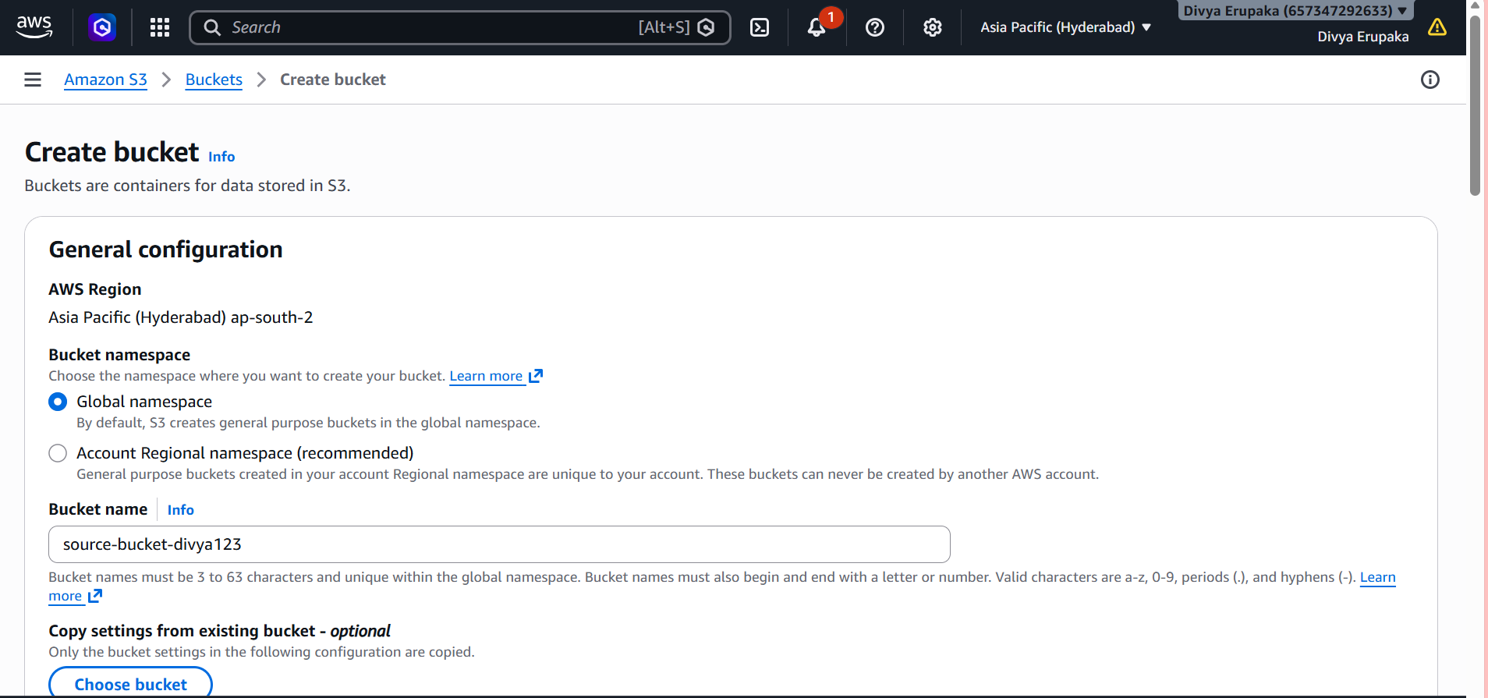
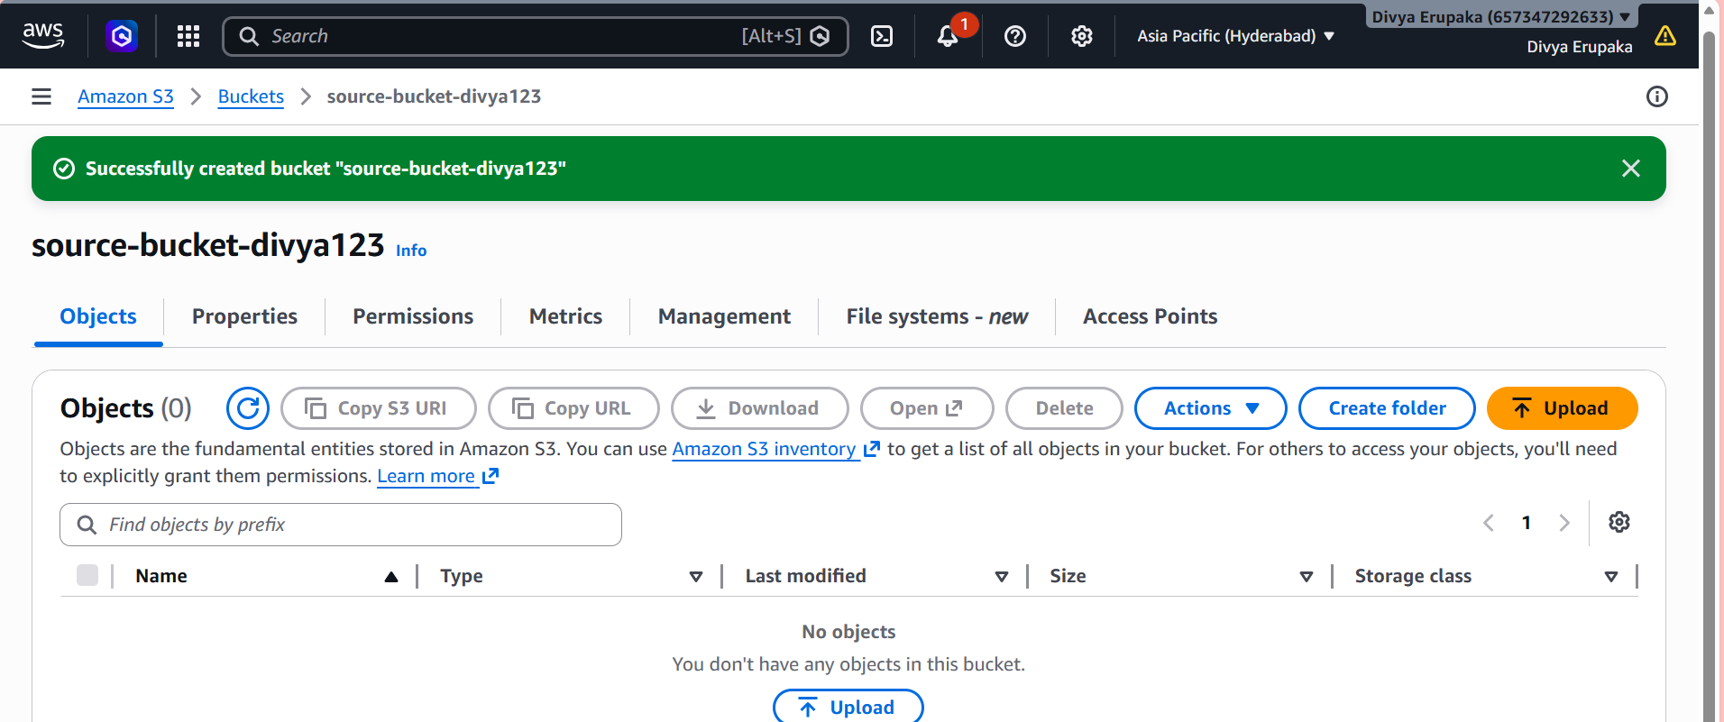
Step 2: Enable Versioning on Source Bucket
- Open-Source Bucket.
- Go to Properties.
- Scroll to Bucket Versioning.
- Click Edit.
- Select: Enable
- Save changes.
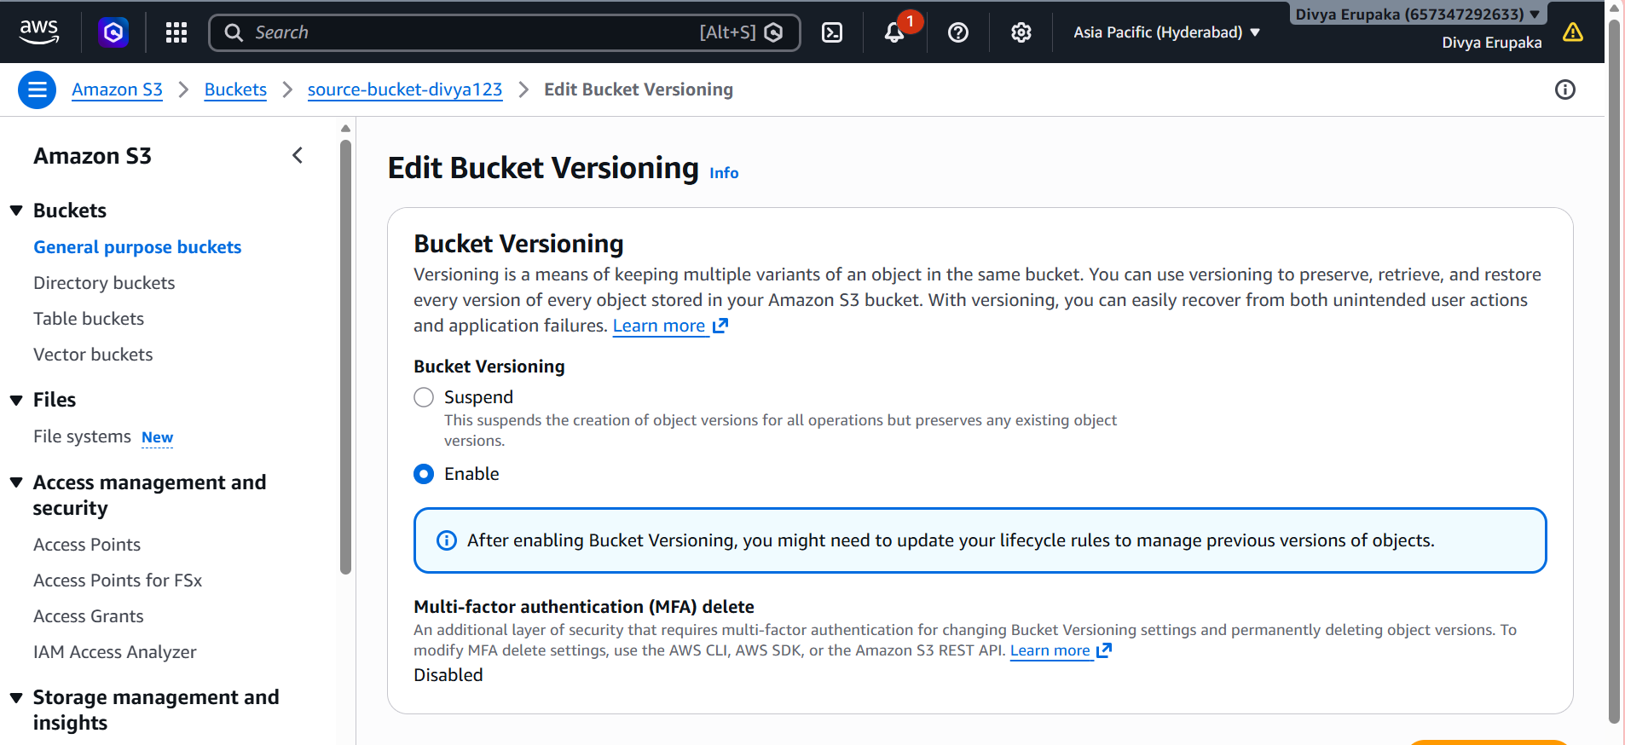
Step 3: Enable Versioning on Destination Bucket
Repeat the same steps for the destination bucket.
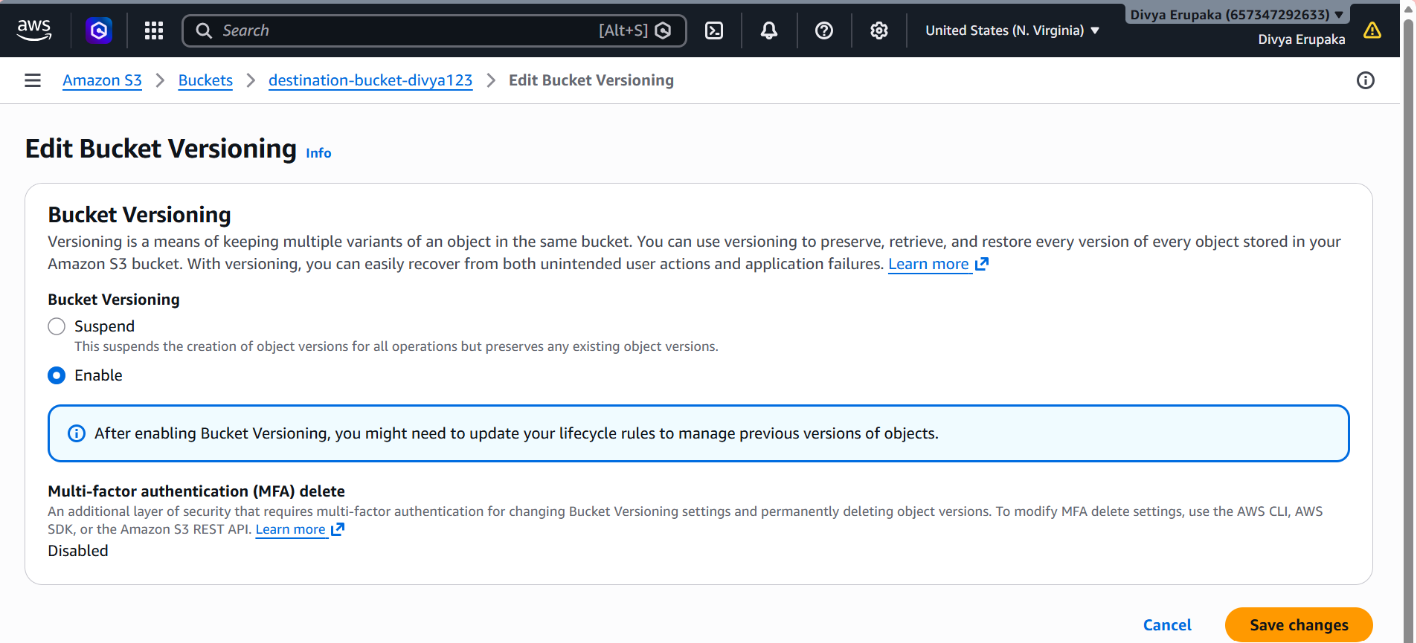Step 4: Configure Replication Rule
- Open Source Bucket.
- Select the Management tab.
- Scroll to Replication rules.
- Click: Create replication rule

Replication Rule Settings
Rule Name CrossRegionReplication
Status Enabled
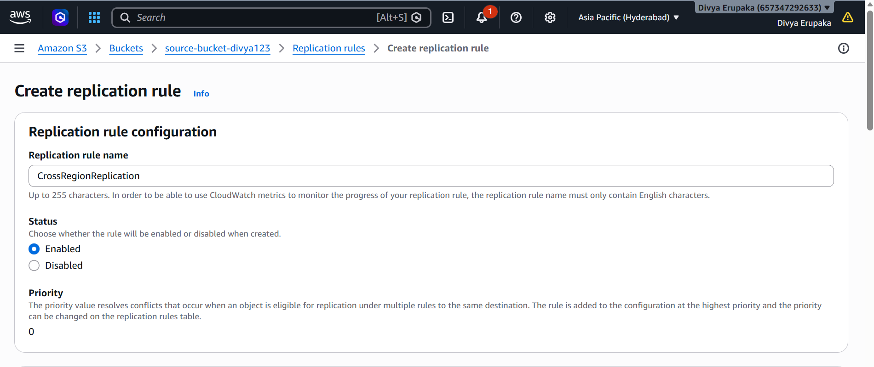
Source Bucket
Choose: Apply to all objects in the bucket

Destination
Select:
Specify a bucket in another account or region
Choose: destination-bucket-divya
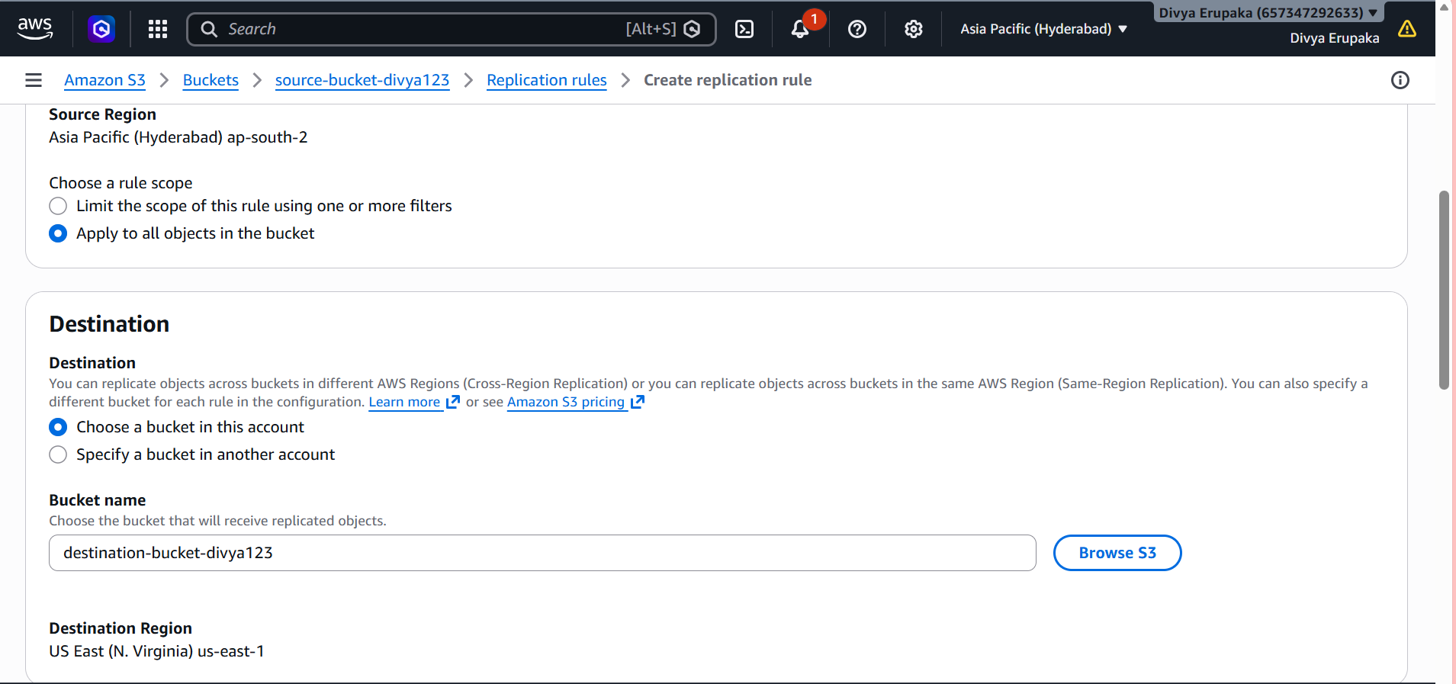
IAM Role
Select: Create a new role
AWS automatically creates the required replication role.
Click: Save
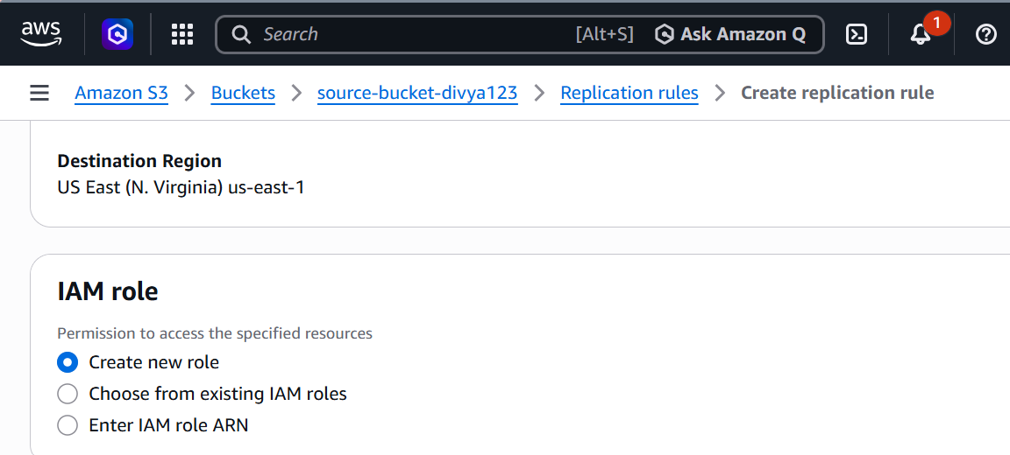
Screenshot Required
- Replication rule configuration
- IAM role created
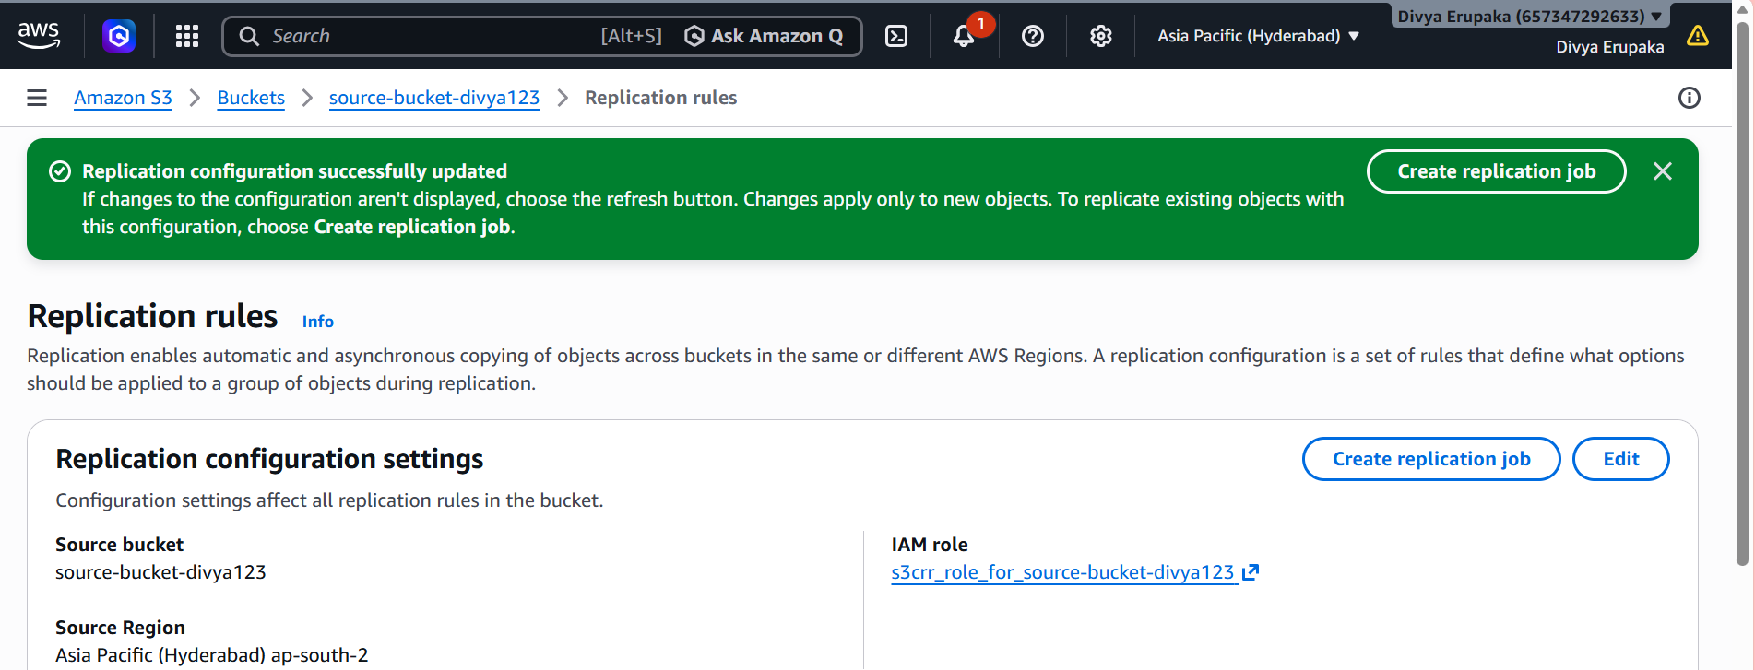
Step 5: Verify Replication Rule
Open:
Source Bucket
→ Management
→ Replication Rules
Expected:
CrossRegionReplication
Status: Enabled
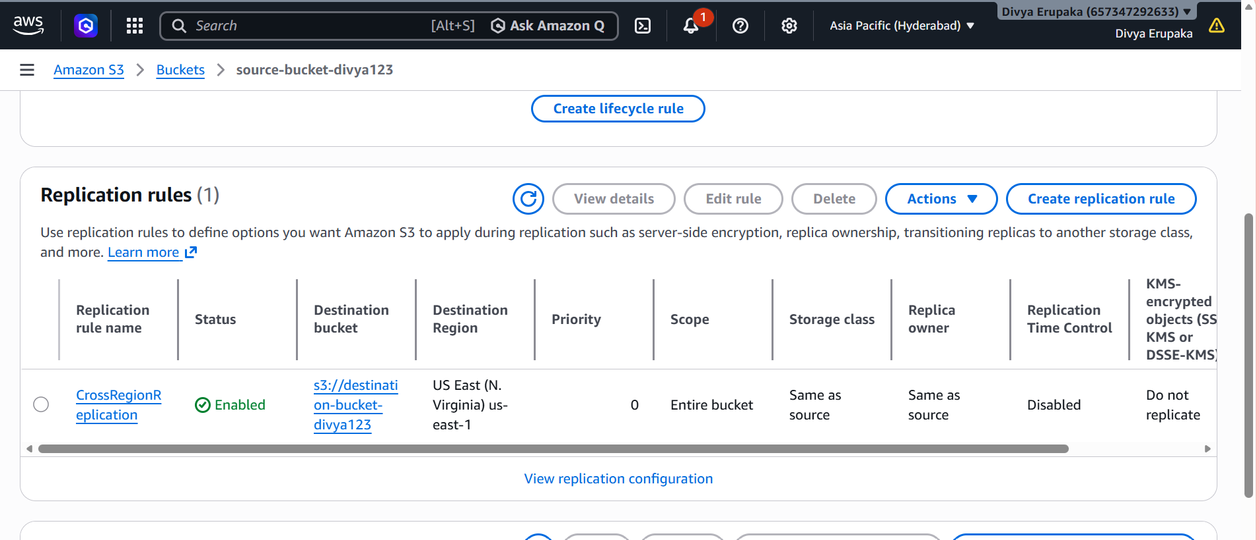
Step 6: Upload a Test Object
Upload a file to the source bucket.
Example:
test-replication.txt
Content:
Cross Region Replication Test
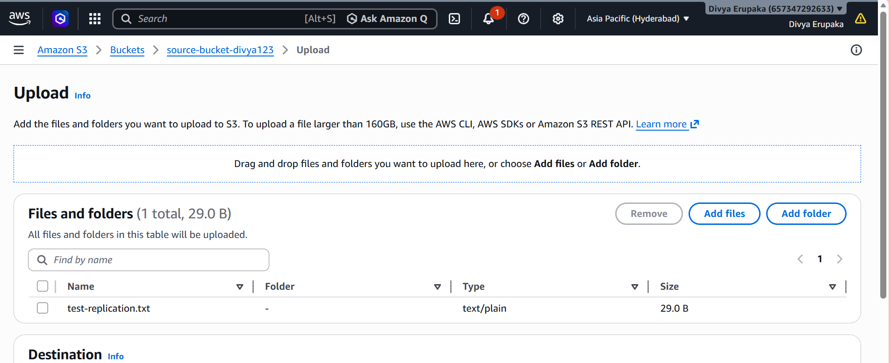
Step 7: Verify Replication
Wait 1–5 minutes.
Open the destination bucket.
Expected:
test-replication.txt
should appear automatically.
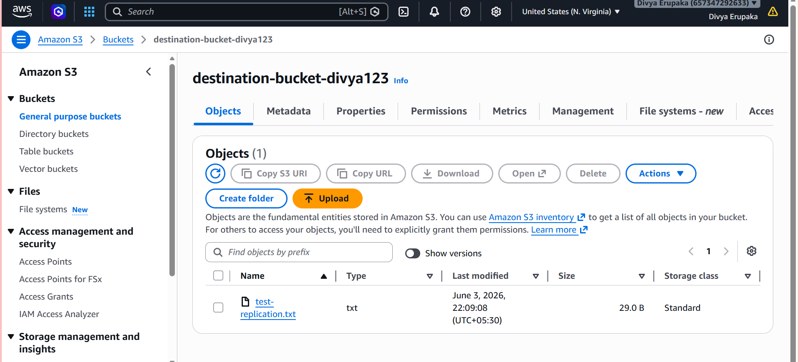
Important Interview Points
What is Cross-Region Replication?
Cross-Region Replication (CRR) automatically copies objects from one S3 bucket to another bucket in a different AWS Region.
Why Use CRR?
- Disaster Recovery
- High Availability
- Compliance Requirements
- Global Access to Data
- Backup Strategy
Result
Successfully configured Amazon S3 Cross-Region Replication between two buckets located in different AWS Regions. Verified that objects uploaded to the source bucket were automatically replicated to the destination bucket.
Task 4: Configure an S3 Bucket Policy so Only the Admin User Can Access Bucket Objects
Objective: Configure an Amazon S3 bucket policy to allow only the IAM user AdminUser to view and access objects stored in the S3 bucket.
Prerequisites
- AWS Account
- Existing S3 Bucket
- IAM User: AdminUser
- Permission to modify bucket policies

Step 1: Identify the AdminUser ARN
- Login to the AWS Management Console.
- Navigate to IAM.
- Select Users.
- Click AdminUser.
- Copy the ARN displayed in the Summary section.
Example:
arn:aws:iam::123456789012:user/AdminUser
Screenshot Required
- IAM User Details page showing the AdminUser ARN.
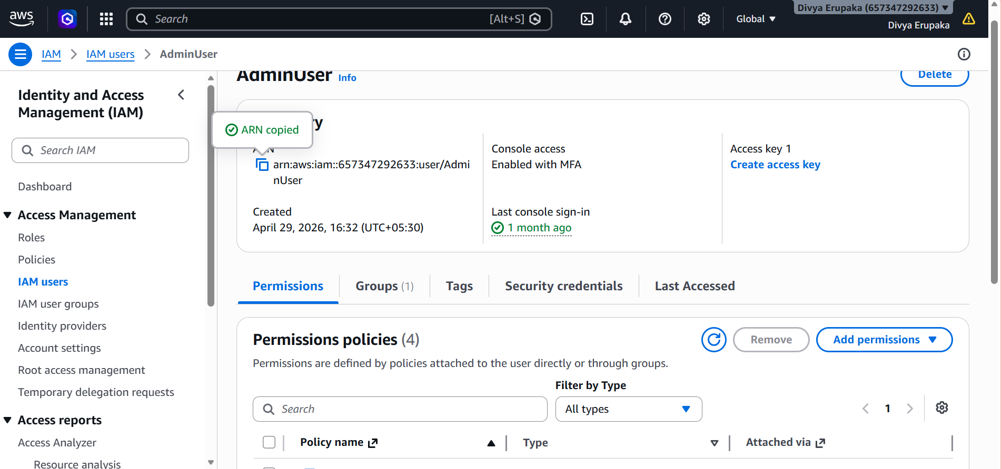
Step 2: Open the S3 Bucket
- Navigate to Amazon S3.
- Open the target bucket.
- Select the Permissions tab.
- Scroll to Bucket Policy.
- Click Edit.
Step 3: Configure the Bucket Policy
Replace the following values before applying the policy:
- ACCOUNT_ID → Your AWS Account ID
- BUCKET_NAME → Your S3 Bucket Name
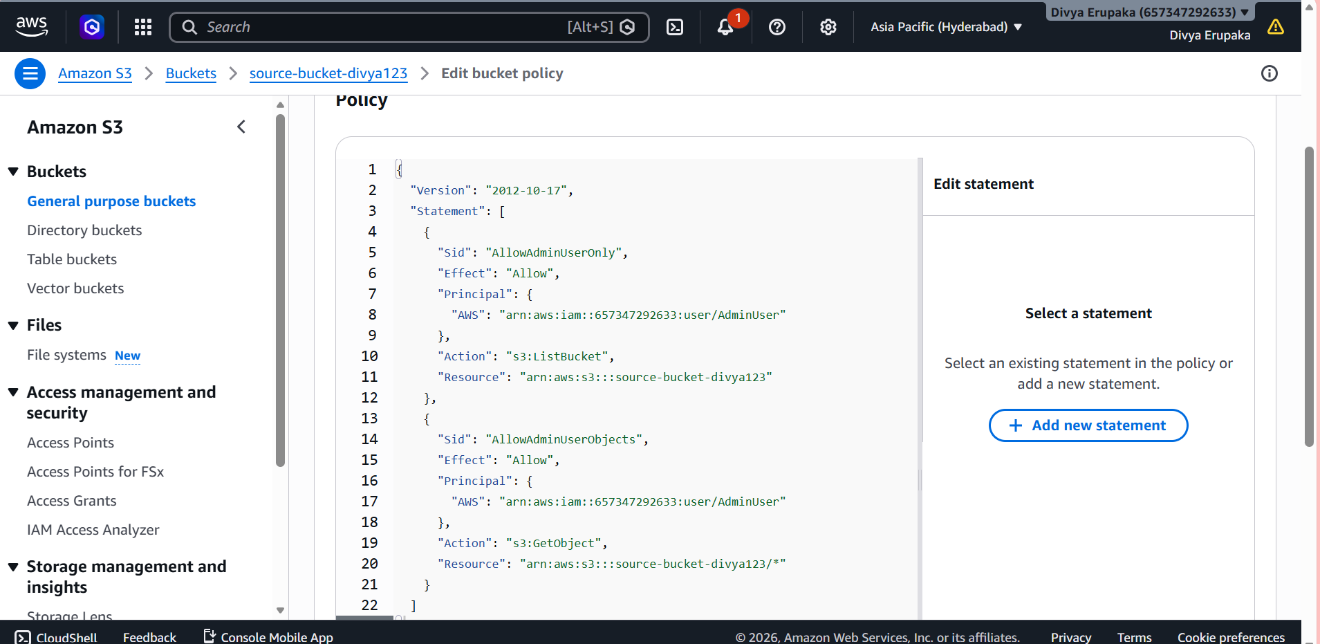
- Click Save Changes.
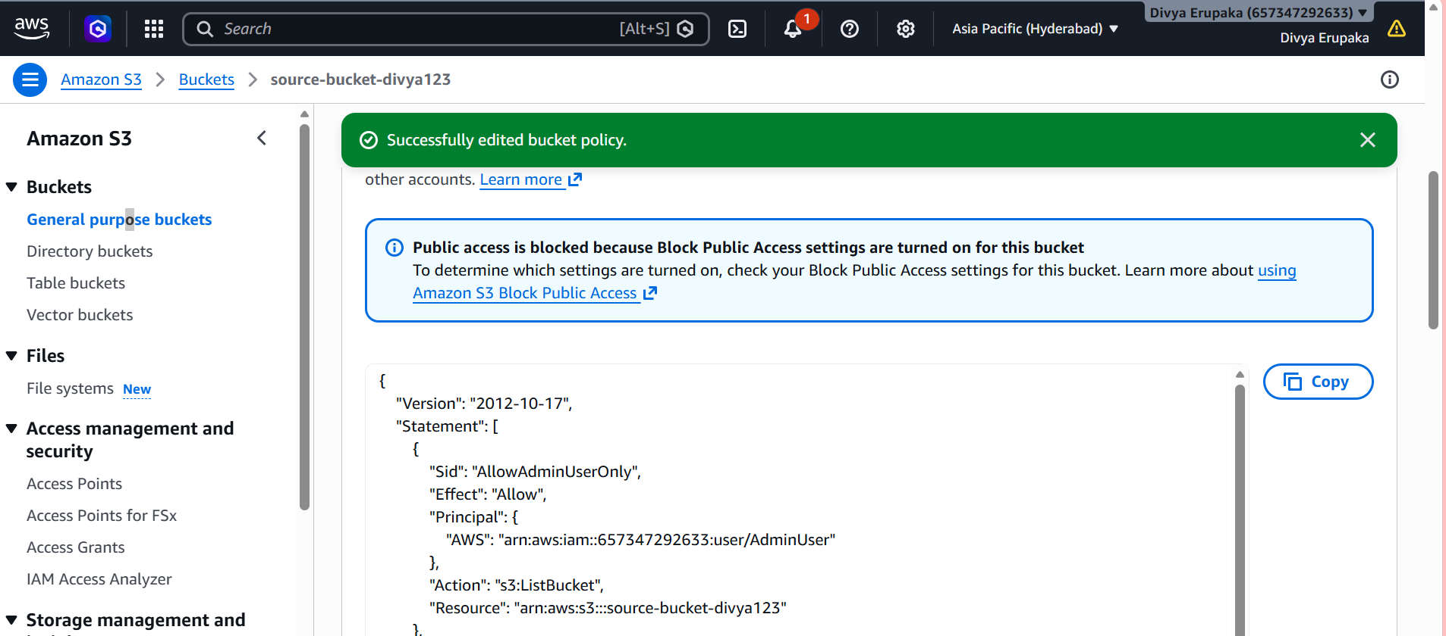Step 4: Verify Access
Verification as AdminUser
- Sign in using the AdminUser account.
- Open the S3 bucket.
- Verify that bucket objects are visible.
- Open or download an object from the bucket.
Expected Result:
AdminUser can list and access bucket objects successfully.
Verification Using Another User (Optional)
- Sign in using another IAM user.
- Attempt to access the bucket objects.
Expected Result:
Access Denied
Screenshot Required
- Successful access using AdminUser.
- Access denied message for other users (if tested).

Expected Outcome
Only the IAM user AdminUser is authorized to list and access objects stored in the S3 bucket. Unauthorized users are prevented from viewing bucket contents.

Result
Successfully configured an S3 bucket policy to restrict object access to the AdminUser IAM account. Verified that the AdminUser can access bucket contents while unauthorized users are denied access.
Task 5: Configure S3 Lifecycle Policies to Automatically Transition or Delete Objects
Objective: Configure an Amazon S3 Lifecycle Policy to automatically manage objects by transitioning them to a different storage class or deleting them after a specified period.

Prerequisites
- AWS Account
- Existing S3 Bucket
- At least one object uploaded to the bucket
- Permission to manage S3 lifecycle rules

What is an S3 Lifecycle Policy?
Amazon S3 Lifecycle Policies help automate object management throughout their lifecycle. Lifecycle rules can:
- Transition objects to lower-cost storage classes.
- Delete objects after a specified period.
- Remove old object versions.
- Optimize storage costs automatically.

Step 1: Open the S3 Bucket
- Sign in to the AWS Management Console.
- Navigate to Amazon S3.
- Open the target bucket.
- Select the Management tab.
Screenshot Required
- S3 Bucket Overview
- Management Tab

Step 2: Create a Lifecycle Rule
- Under Lifecycle Rules, click Create lifecycle rule.
Rule Configuration
Rule Name:
DeleteOldObjects
Rule Scope:
Apply to all objects in the bucket
Select:
I acknowledge that this rule will apply to all objects in the bucket.
Screenshot Required
- Lifecycle Rule Creation Page
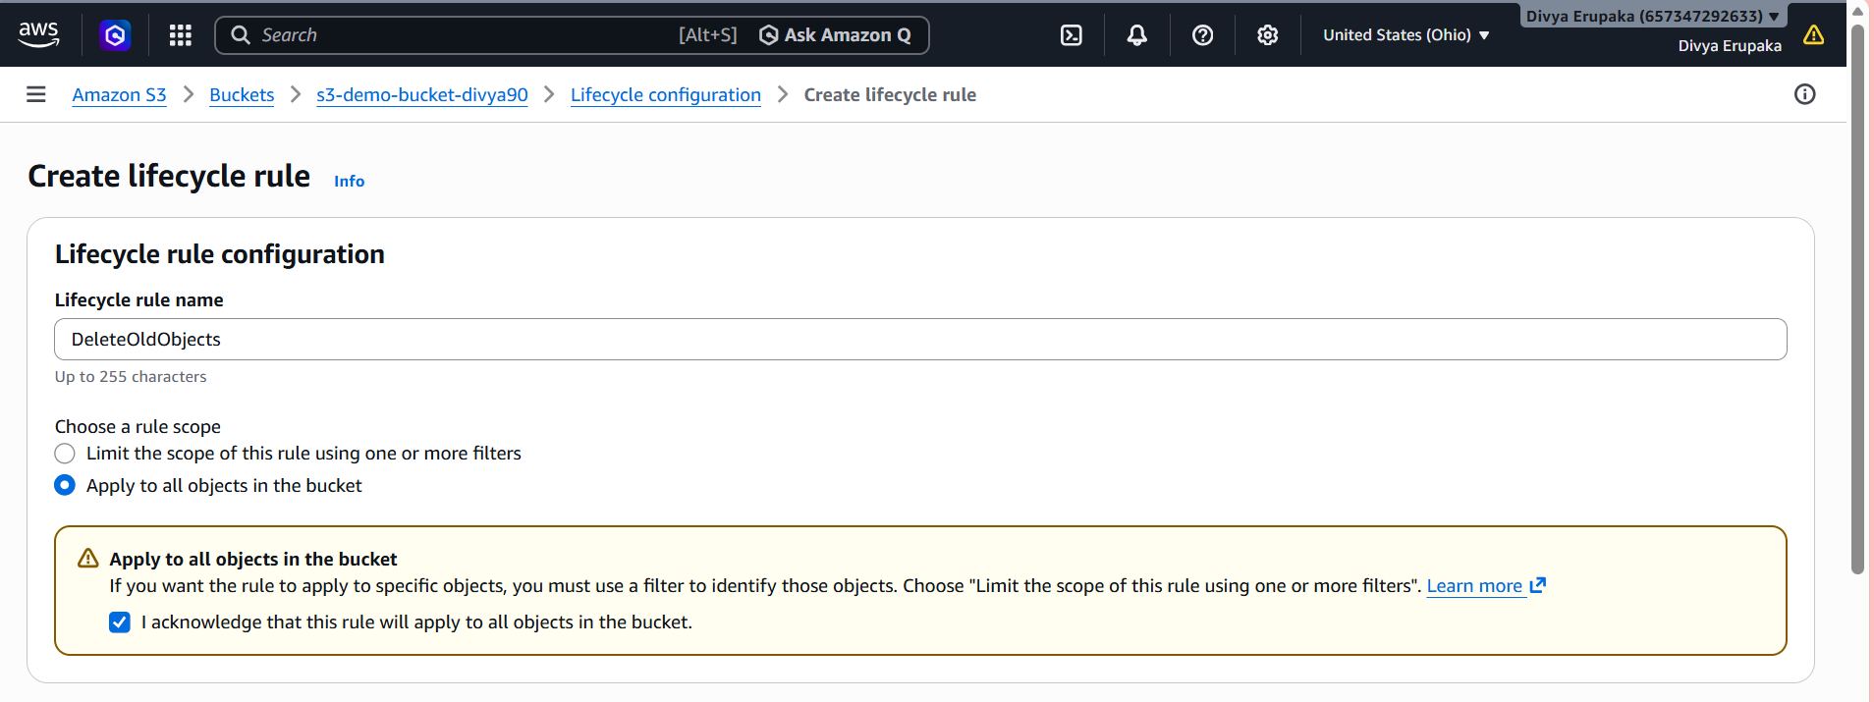
Step 3: Configure Lifecycle Actions
Option A: Transition Objects (Recommended for Learning)
Select:
Move current versions of objects between storage classes
Configure:
Transition After | Storage Class
30 Days | S3 Standard-IA
This moves objects to a lower-cost storage class after 30 days.

Option B: Expire/Delete Objects (Common Assignment Requirement)
Select:
Expire current versions of objects
Configure:
Days after object creation: 30
This automatically deletes objects after 30 days.
Note
For demonstration purposes, you may use:
1 Day
to show the lifecycle rule configuration.
Screenshot Required
- Lifecycle Action Configuration
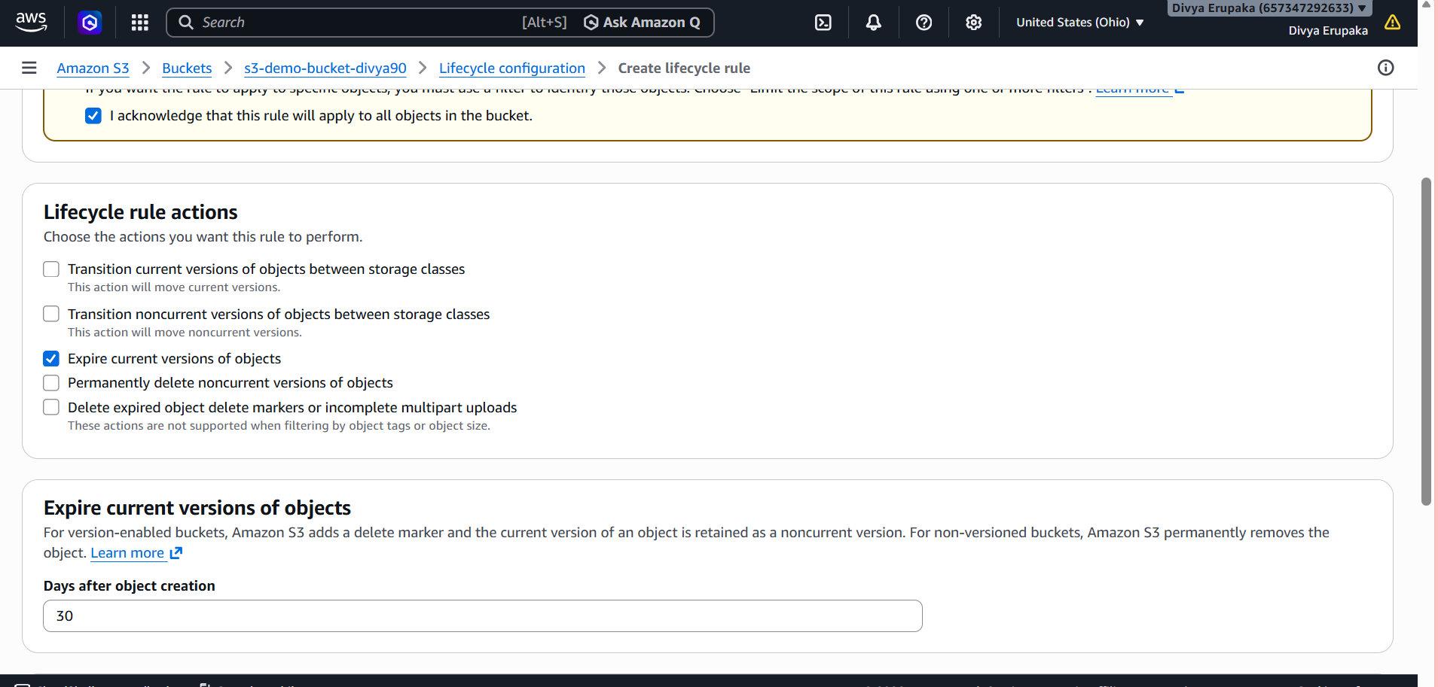
Step 4: Review and Create Rule
- Review the lifecycle configuration.
- Click Create Rule.
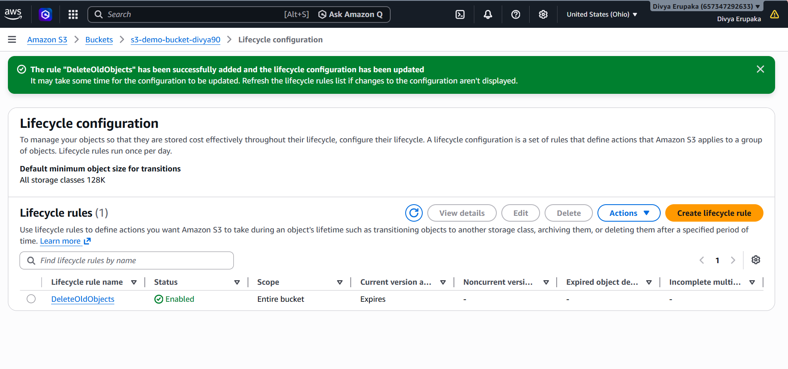Step 5: Verify Lifecycle Rule
Navigate to:
S3 Bucket
→ Management
→ Lifecycle Rules
Verify the rule appears:
DeleteOldObjects
Status: Enabled
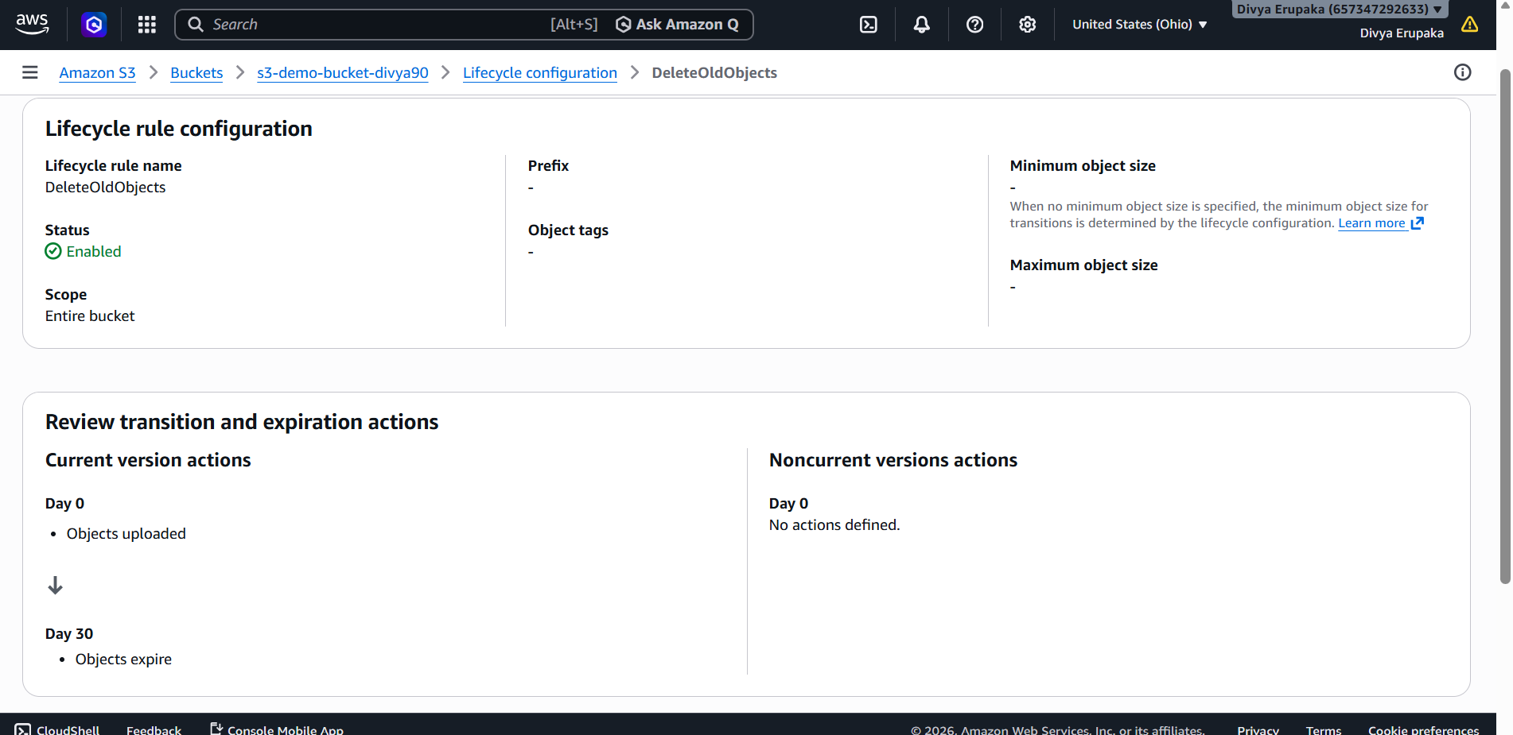

Expected Outcome
The lifecycle rule automatically manages S3 objects based on the configured criteria, reducing manual administration and optimizing storage costs.

Result
Successfully configured an Amazon S3 Lifecycle Policy to automatically transition or delete objects after a specified period. Verified that the lifecycle rule is enabled and associated with the S3 bucket.
Task 6: Upload Objects to Amazon S3 Using AWS CLI
Objective: Upload files (objects) to an Amazon S3 bucket using AWS Command Line Interface (AWS CLI).

Prerequisites
- AWS Account
- Existing S3 Bucket
- AWS CLI installed
- AWS CLI configured with valid credentials

Step 1: Verify AWS CLI Installation
Open Command Prompt, PowerShell, or Terminal and run:
aws --version
Expected Output:
aws-cli/2.x.x Python/3.x.x Windows/10 exe/AMD64
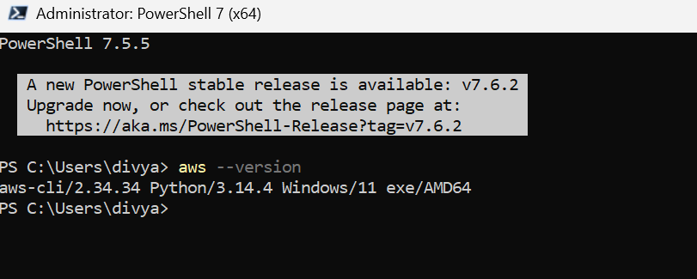
Step 2: Configure AWS CLI
Run:
aws configure
Enter:
AWS Access Key ID
AWS Secret Access Key
Default region name
Default output format
Example:
AWS Access Key ID: AKIAxxxxxxxxxxxx
AWS Secret Access Key: ****************
Default region name: ap-south-1
Default output format: json
Verify configuration:
aws sts get-caller-identity
Expected Output:
{
"UserId": "XXXXXXXXXXXX",
"Account": "XXXXXXXXXXXX",
"Arn": "arn:aws:iam::XXXXXXXXXXXX:user/AdminUser"
}
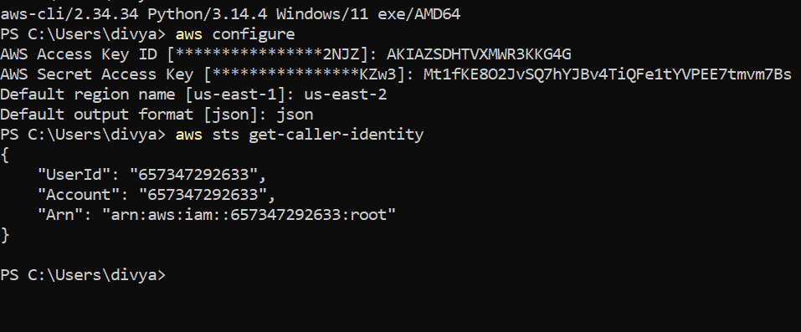
Step 3: Create Sample Files
Create test files locally.
Example:
echo "This is file 1" > file1.txt
echo "This is file 2" > file2.txt
Or create files manually using Notepad.
Example Files:
file1.txt
file2.txt
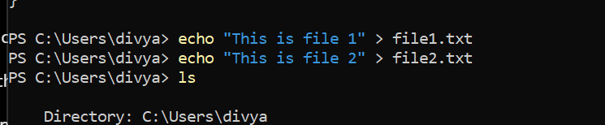
Step 4: Upload a Single File to S3
Command:
aws s3 cp file1.txt s3://YOUR_BUCKET_NAME/
Example:
aws s3 cp file1.txt s3://source-bucket-divya123/
Expected Output:
upload: .\file1.txt to s3://source-bucket-divya123/file1.txt
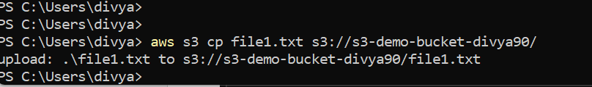
Step 5: Upload Multiple Files
Command:
aws s3 cp file2.txt s3://YOUR_BUCKET_NAME/
Example:
aws s3 cp file2.txt s3://source-bucket-divya123/
Expected Output:
upload: .\file2.txt to s3://source-bucket-divya123/file2.txt
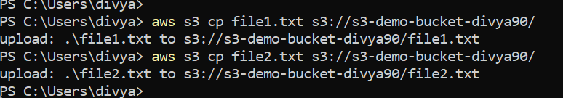
Step 6: Verify Uploaded Objects
List bucket contents:
aws s3 ls s3://source-bucket-divya123/
Expected Output:
2026-06-04 10:20:15 15 file1.txt
2026-06-04 10:20:30 15 file2.txt
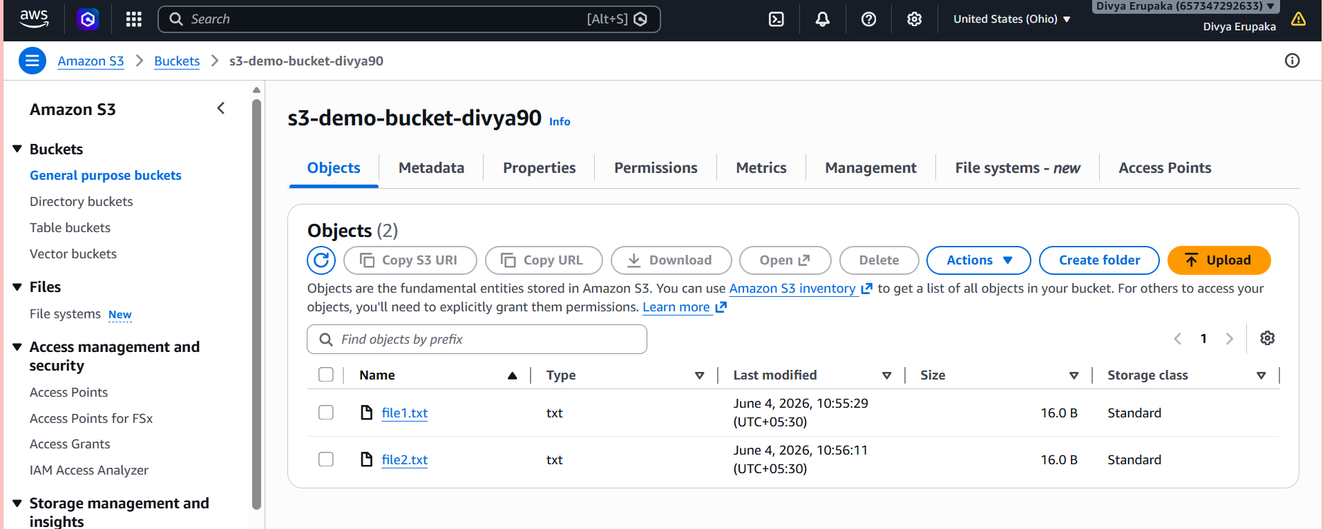
Verification
AWS CLI Verification:
aws s3 ls s3://source-bucket-divya123/
AWS Console Verification:
- Open Amazon S3.
- Open the bucket.
- Verify uploaded objects are visible.
Result
Successfully uploaded objects to Amazon S3 using AWS CLI and verified the uploaded files using both AWS CLI and the AWS Management Console.
Task 7: Upload Objects to Amazon S3 Using AWS CLI
Objective: Upload files (objects) to an Amazon S3 bucket using AWS Command Line Interface (AWS CLI).

Prerequisites
- AWS Account
- Existing S3 Bucket
- AWS CLI installed
- AWS CLI configured with valid credentials

Step 1: Verify AWS CLI Installation
Open Command Prompt, PowerShell, or Terminal and run:
aws --version
Expected Output:
aws-cli/2.x.x Python/3.x.x Windows/10 exe/AMD64
Step 2: Configure AWS CLI
Run:aws configure
Enter:
AWS Access Key ID
AWS Secret Access Key
Default region name
Default output format
Example:
AWS Access Key ID: AKIAxxxxxxxxxxxx
AWS Secret Access Key: ****************
Default region name: ap-south-1
Default output format: json
Verify configuration:
aws sts get-caller-identity
Expected Output:
{
"UserId": "XXXXXXXXXXXX",
"Account": "XXXXXXXXXXXX",
"Arn": "arn:aws:iam::XXXXXXXXXXXX:user/AdminUser"
}


Step 3: Create the Bash Script
Create a file named:
create-s3-bucket.sh
Add the following content:
#!/bin/bash

# Bucket Configuration
BUCKET_NAME="divya-s3-bucket-$(date +%s)"
REGION="ap-south-1"

echo "===================================="
echo "Creating S3 Bucket"
echo "Bucket Name: $BUCKET_NAME"
echo "Region: $REGION"
echo "===================================="

aws s3api create-bucket \
--bucket $BUCKET_NAME \
--region $REGION \
--create-bucket-configuration LocationConstraint=$REGION

if [ $? -eq 0 ]
then
echo "Bucket created successfully."
echo "Bucket Name: $BUCKET_NAME"
else
echo "Bucket creation failed."
fi
Script Explanation
Command | Purpose
#!/bin/bash | Defines the Bash interpreter
BUCKET_NAME | Stores the bucket name
$(date +%s) | Generates a unique timestamp
REGION | Defines AWS Region
aws s3api create-bucket | Creates the S3 bucket
$? | Checks command execution status
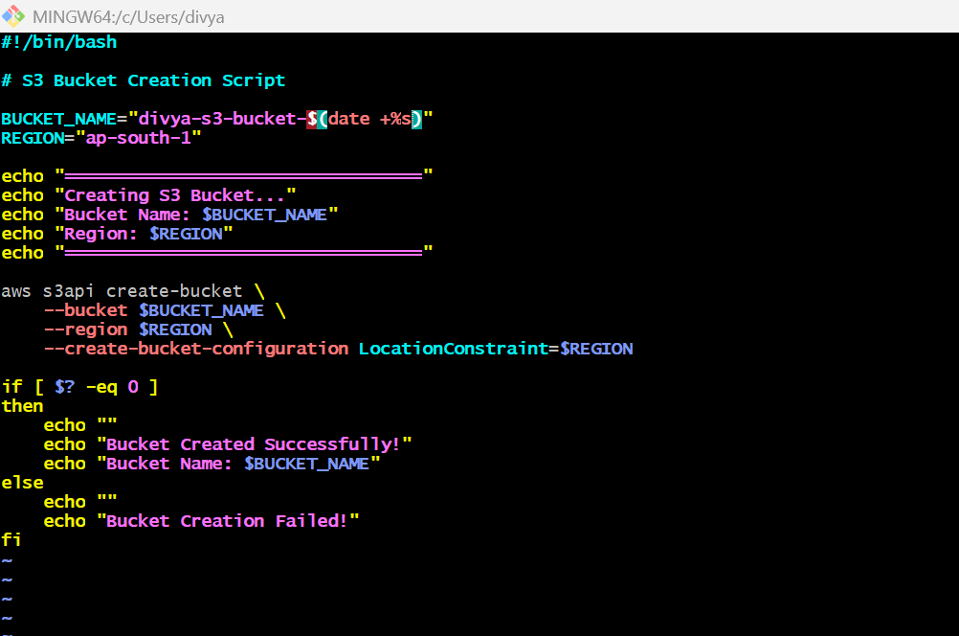
Step 4: Grant Execute Permission
Run:
chmod +x create-s3-bucket.sh
Verify:
ls -ltr
Expected Output:
-rwxr-xr-x create-s3-bucket.sh
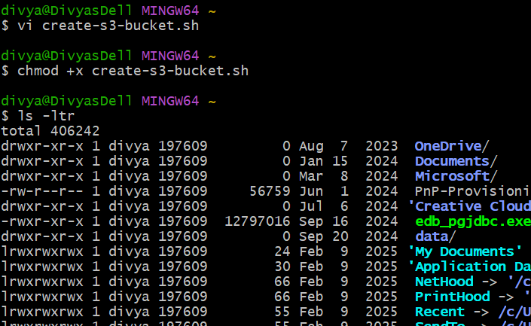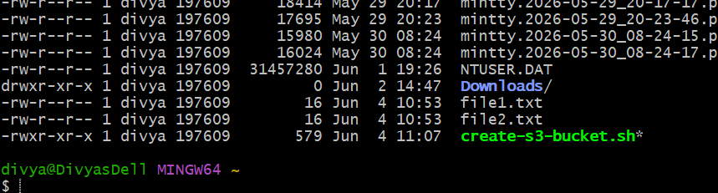
Step 5: Execute the Script
Run:
./create-s3-bucket.sh
Expected Output:
====================================
Creating S3 Bucket
Bucket Name: divya-s3-bucket-1749030000
Region: ap-south-1
====================================

Bucket created successfully.
Bucket Name: divya-s3-bucket-1749030000
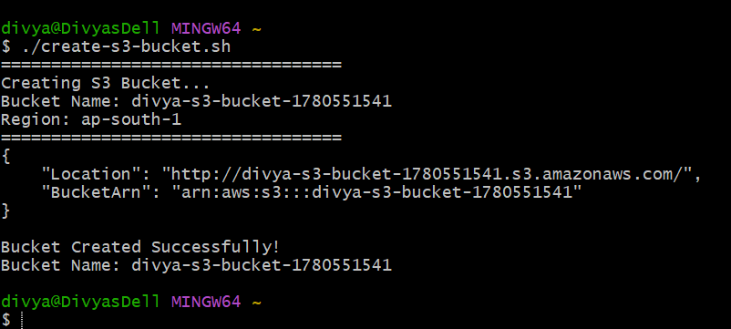
Step 6: Verify Bucket Creation
List all buckets:
aws s3 ls
Expected Output:
2026-06-04 10:30:00 divya-s3-bucket-1749030000
Alternative Verification:
aws s3api head-bucket --bucket <bucket-name>
Example:
aws s3api head-bucket --bucket divya-s3-bucket-1749030000
Screenshot Required
- AWS CLI verification
- S3 Console verification

Validation
AWS CLI Validation
aws s3 ls
Verify that the newly created bucket appears in the output.
AWS Console Validation
- Open Amazon S3.
- Navigate to Buckets.
- Confirm the newly created bucket is listed.
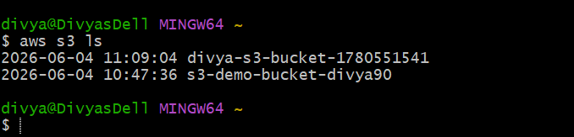
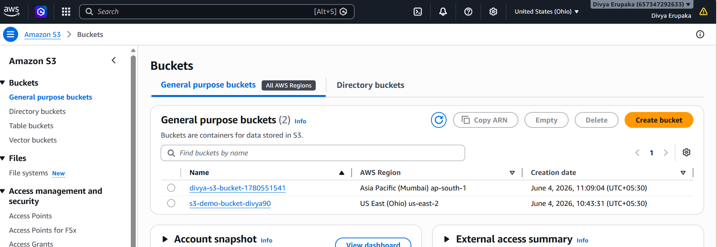
Result
Successfully created an Amazon S3 bucket using a Bash script and AWS CLI. Verified bucket creation through AWS CLI commands and the AWS Management Console.
Task 8: Upload a 1 GB File to Amazon S3 Using AWS CLI
Objective: Create a 1 GB test file and upload it to an Amazon S3 bucket using the AWS Command Line Interface (AWS CLI).

Prerequisites
- AWS Account
- Existing S3 Bucket
- AWS CLI installed and configured
- IAM User with S3 permissions

Step 1: Verify AWS CLI Configuration
Run:
aws sts get-caller-identity
Expected Output:
{
"Account": "XXXXXXXXXXXX",
"Arn": "arn:aws:iam::XXXXXXXXXXXX:user/AdminUser"
}
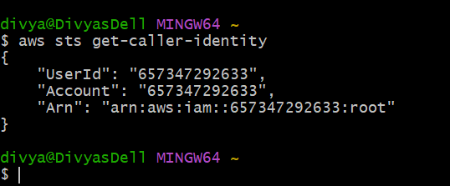
Step 2: Create a 1 GB Test File
Linux / EC2 / CloudShell
dd if=/dev/zero of=1GB-TestFile.bin bs=1M count=1024
Verify file size:
ls -lh 1GB-TestFile.bin
Expected Output:
-rw-r--r-- 1 ec2-user ec2-user 1.0G 1GB-TestFile.bin
Screenshot Required
- 1 GB file creation
- File size verification

Step 3: Upload File to S3
Replace the bucket name with your bucket.
aws s3 cp 1GB-TestFile.bin s3://source-bucket-divya123/
Expected Output:
upload: ./1GB-TestFile.bin to s3://source-bucket-divya123/1GB-TestFile.bin
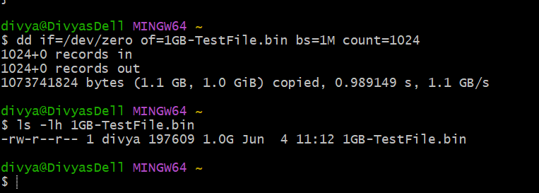
Step 4: Verify Upload Using AWS CLI
Run:
aws s3 ls s3://source-bucket-divya123/
Expected Output:
2026-06-04 12:15:00 1073741824 1GB-TestFile.bin
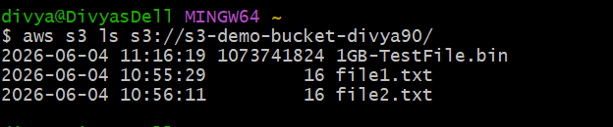
Step 5: Verify Upload from AWS Console
- Open AWS Console.
- Navigate to Amazon S3.
- Open the bucket.
- Verify the file exists.
Expected:
1GB-TestFile.bin
Size: 1.0 GB
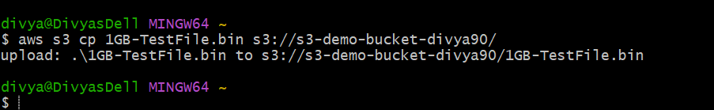
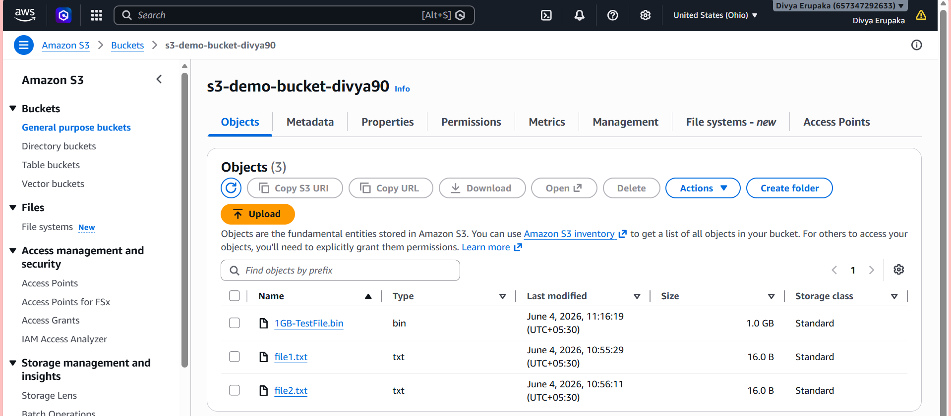
Result
Successfully created a 1 GB test file and uploaded it to Amazon S3 using AWS CLI. Verified the upload using both AWS CLI commands and the AWS Management Console.

